SKRIPSI_ASEP2

*by* Student _

**Submission date:** 01-Jul-2022 08:51PM (UTC-0700)

**Submission ID:** 1865648176 **File name:** Join.docx (740.24K) **Word count:** 4674

**Character count:** 32188

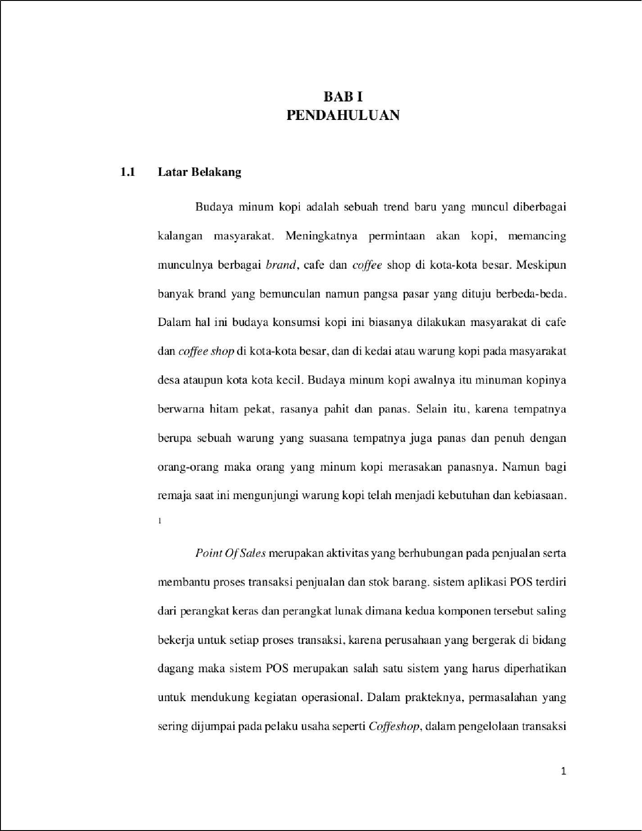

29

6

9

9

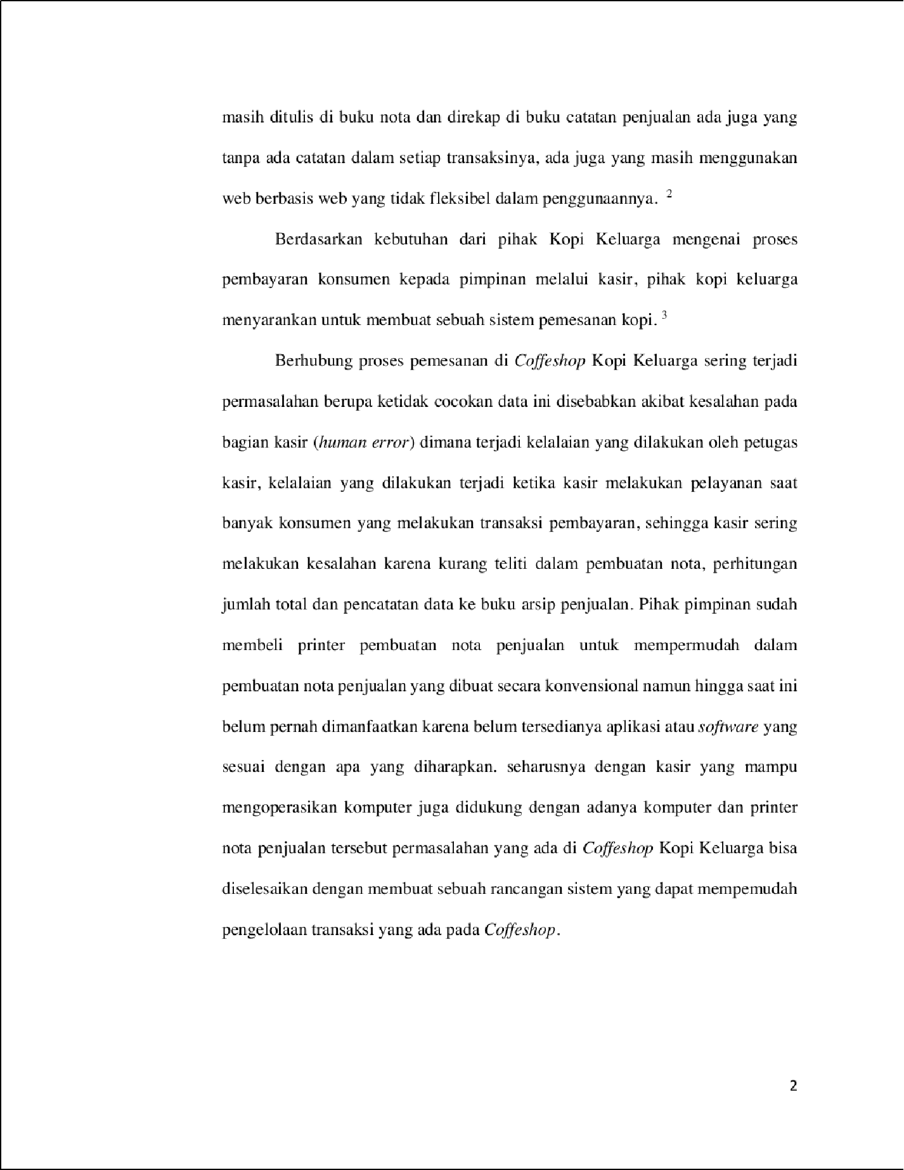

7

17

7

27

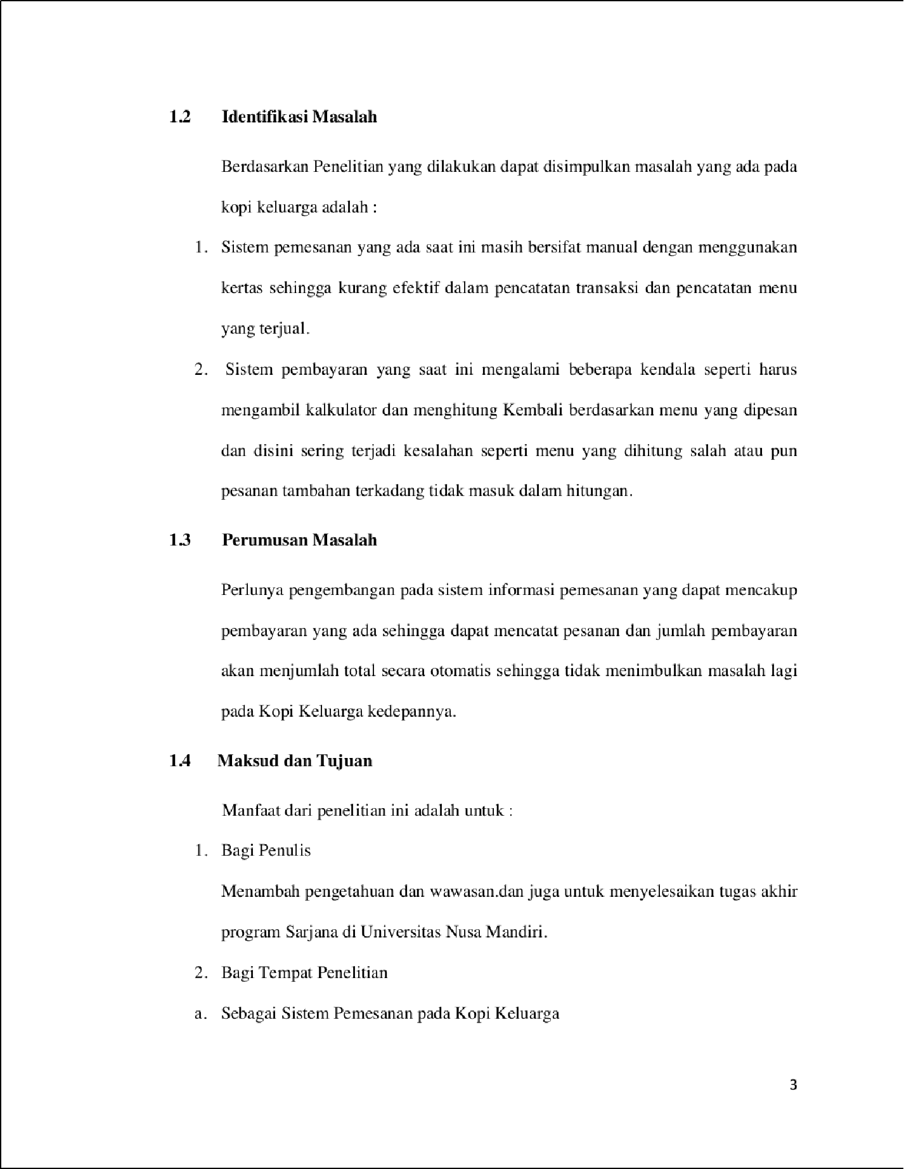

56

64

29

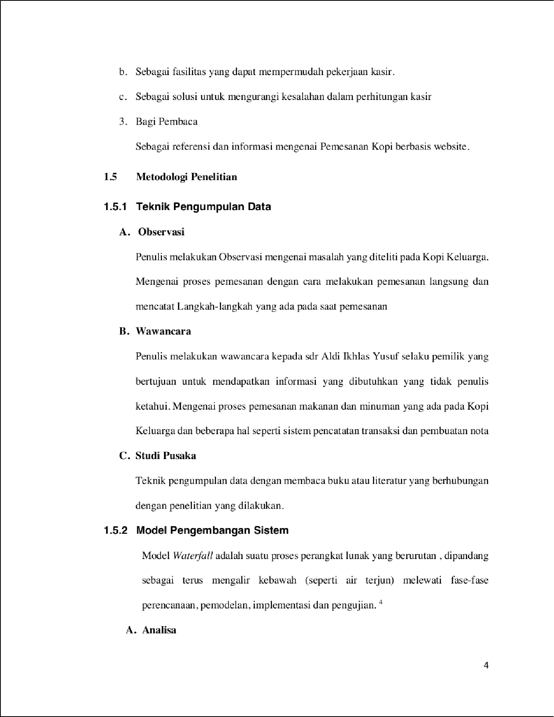

49

61

7

30

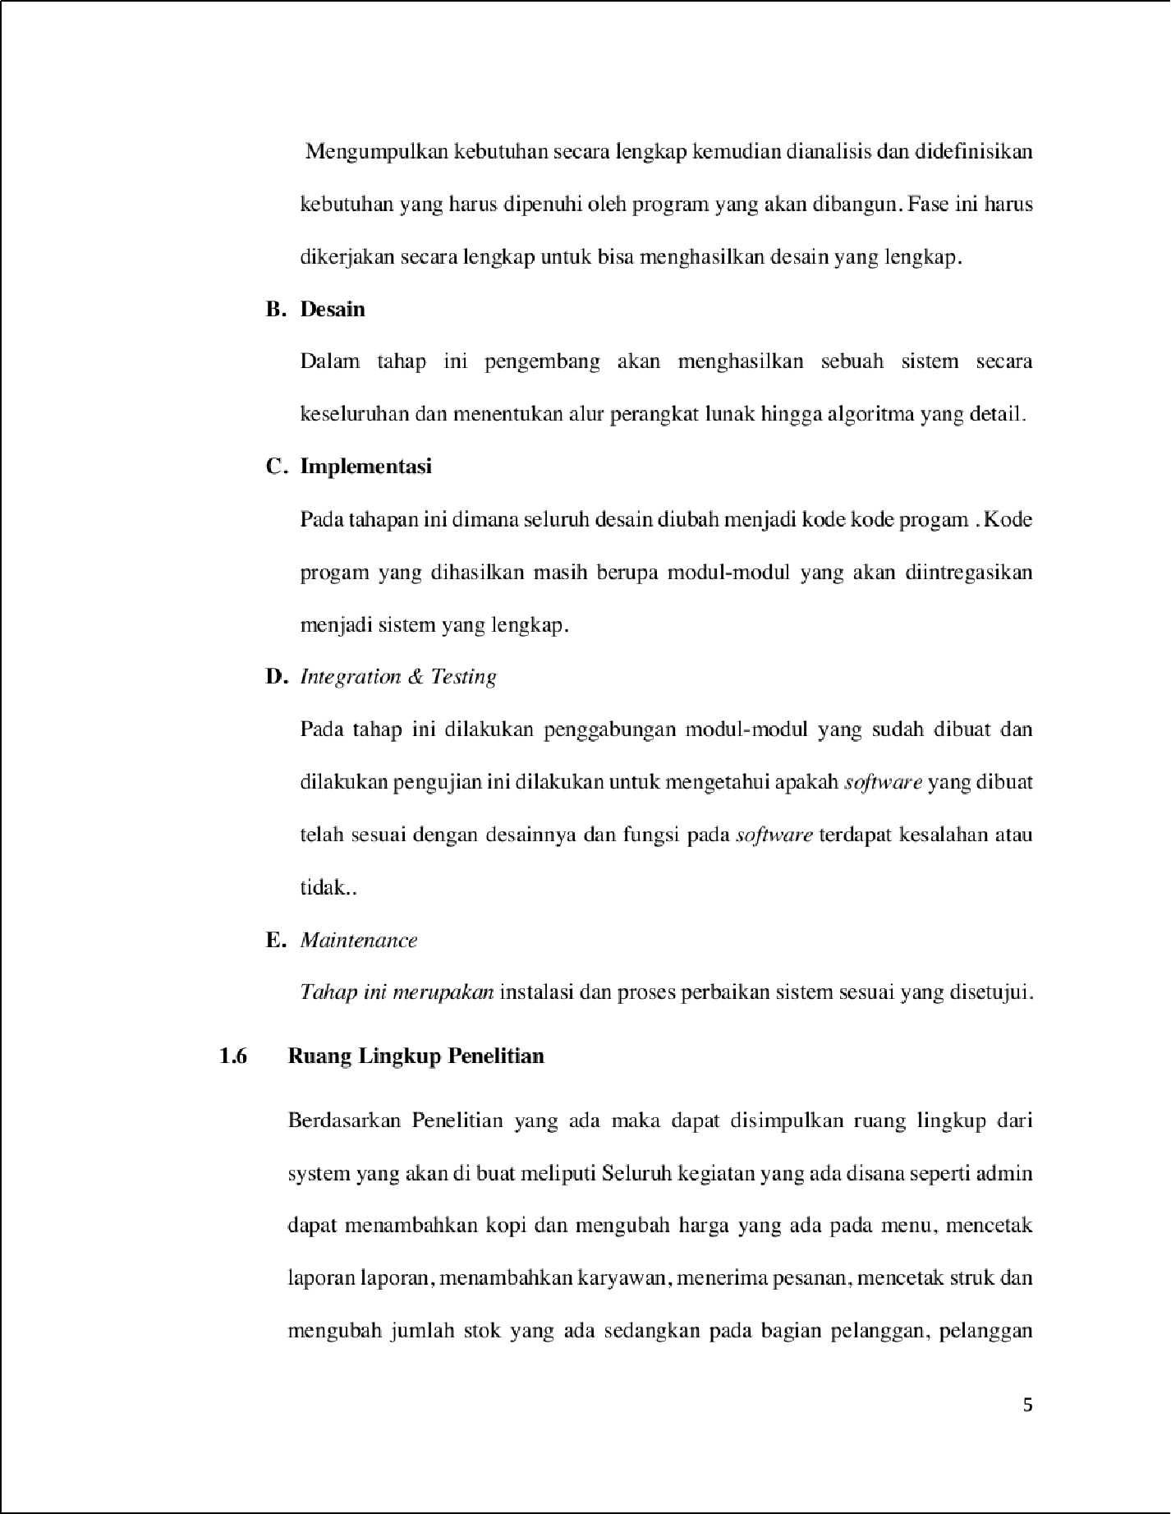

4

51

40



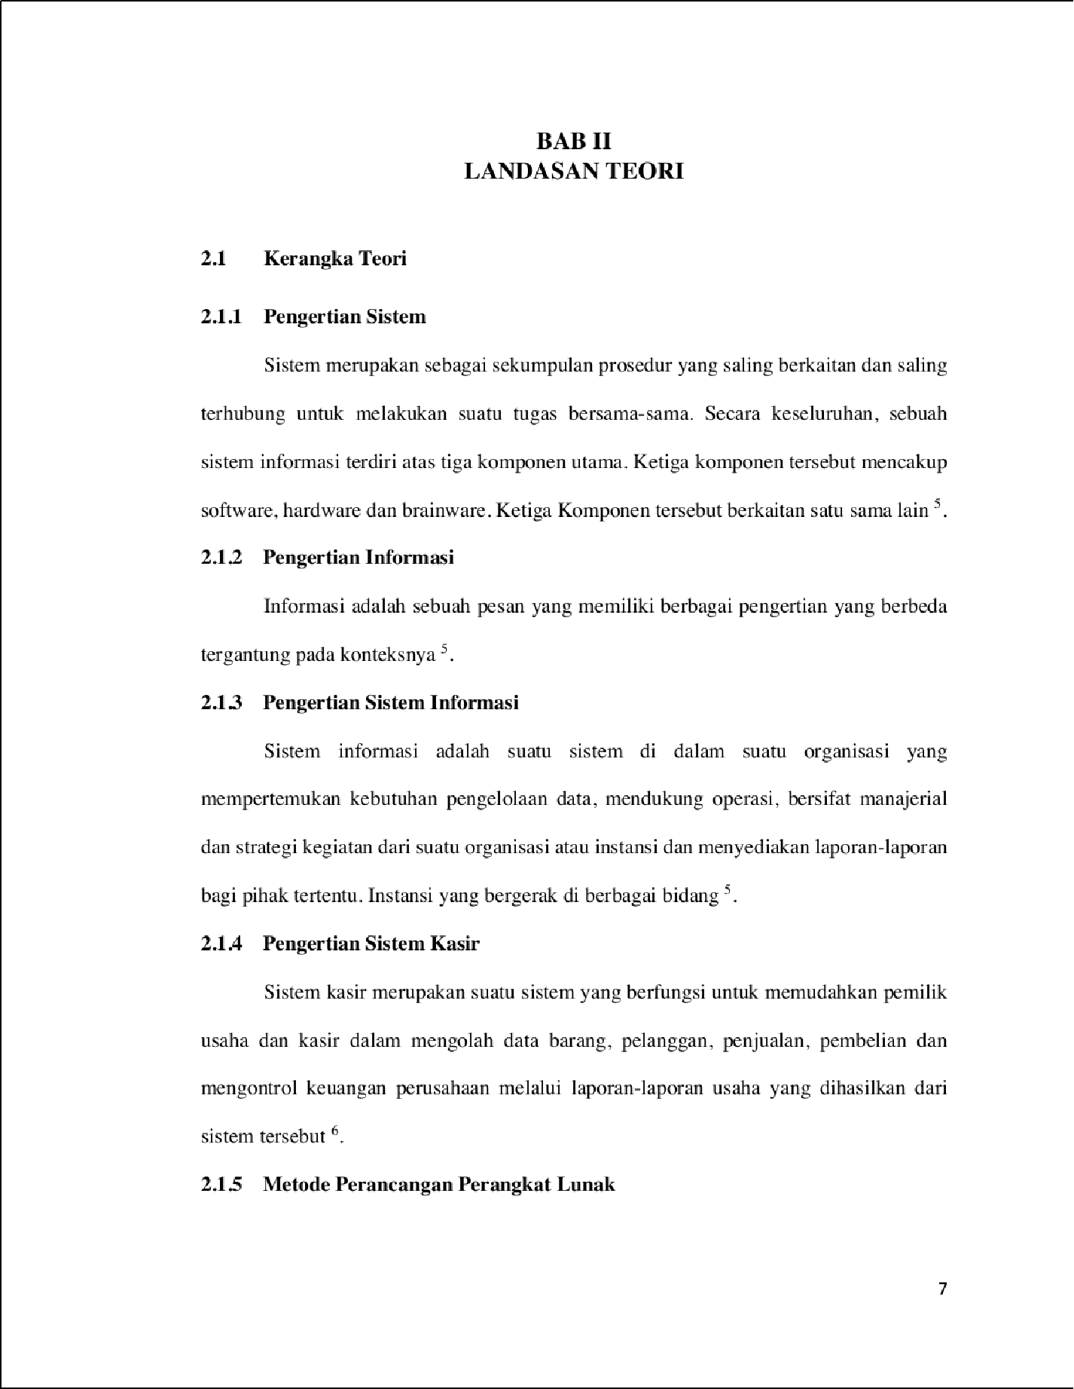

1

21

44

24

17

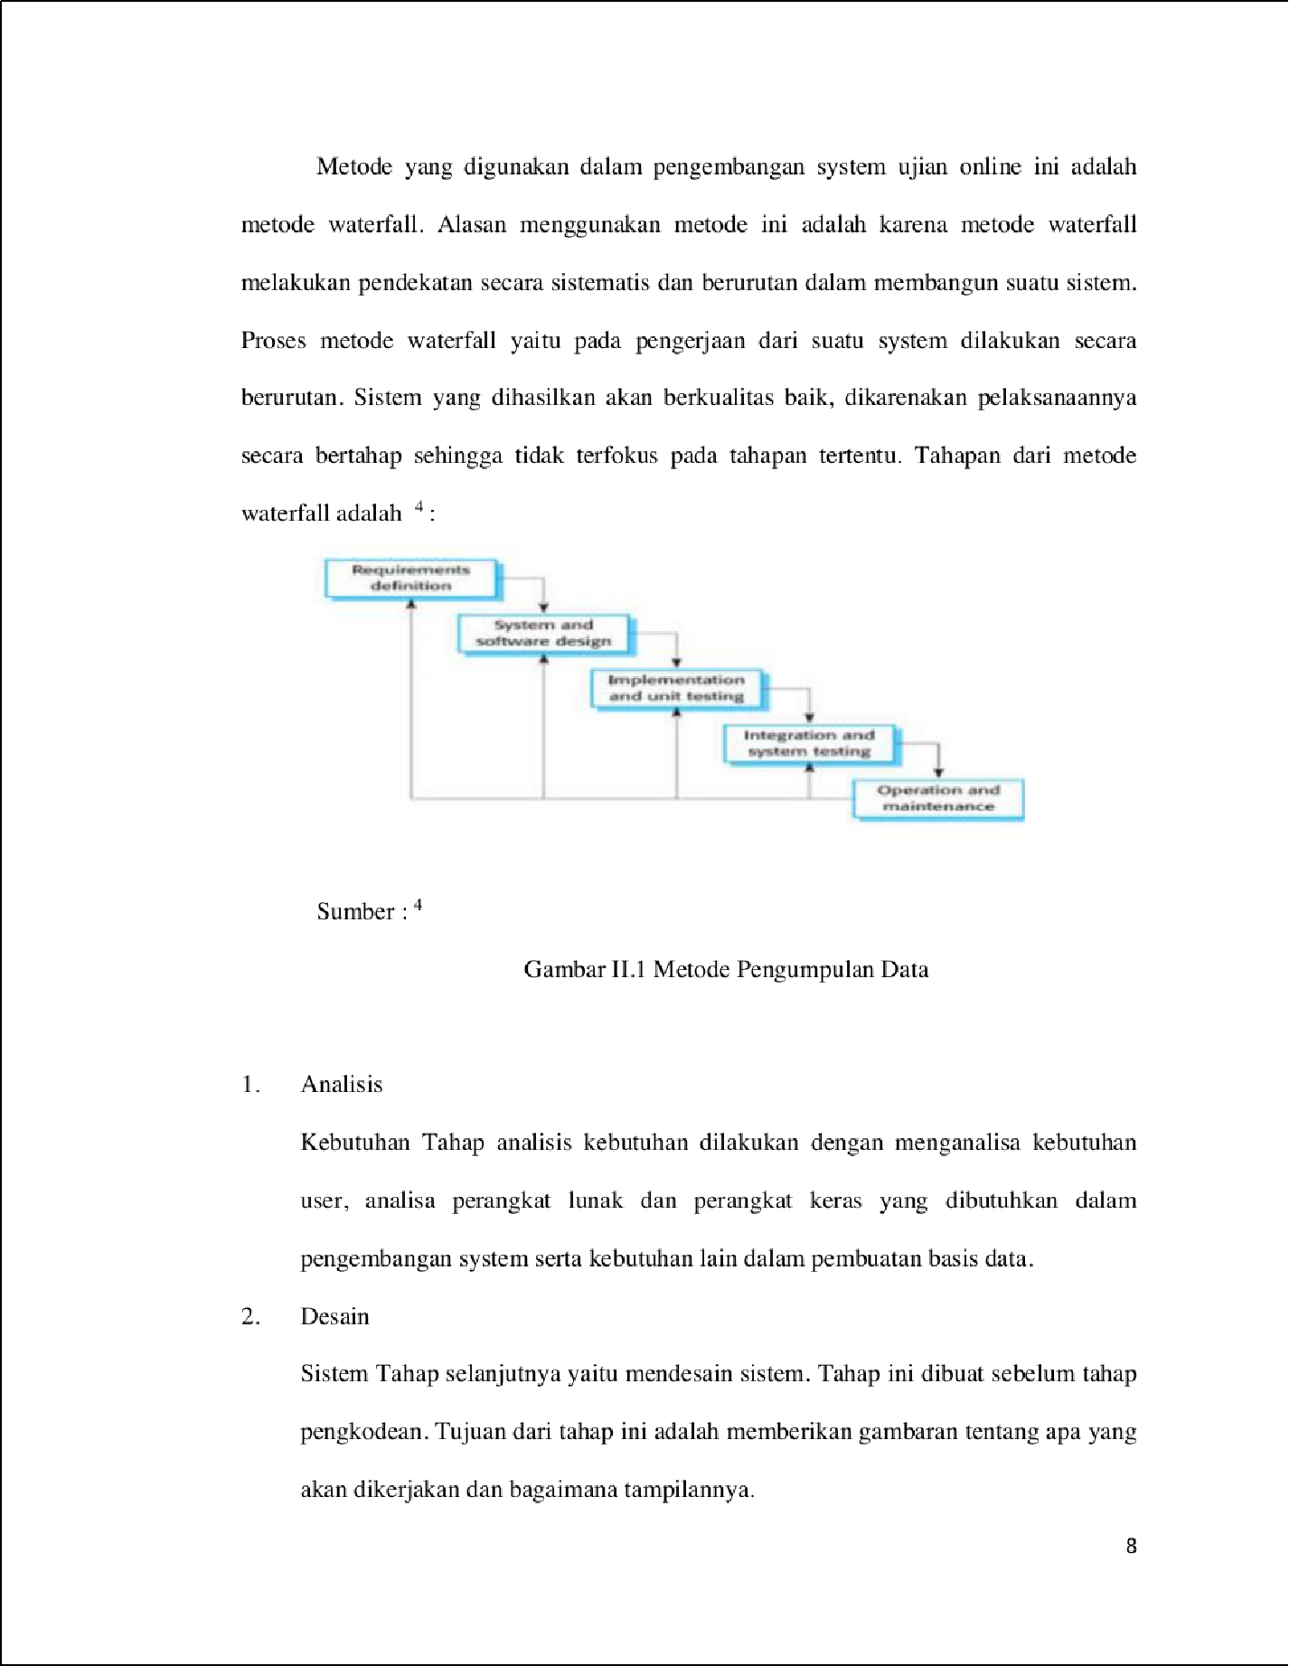

2

13

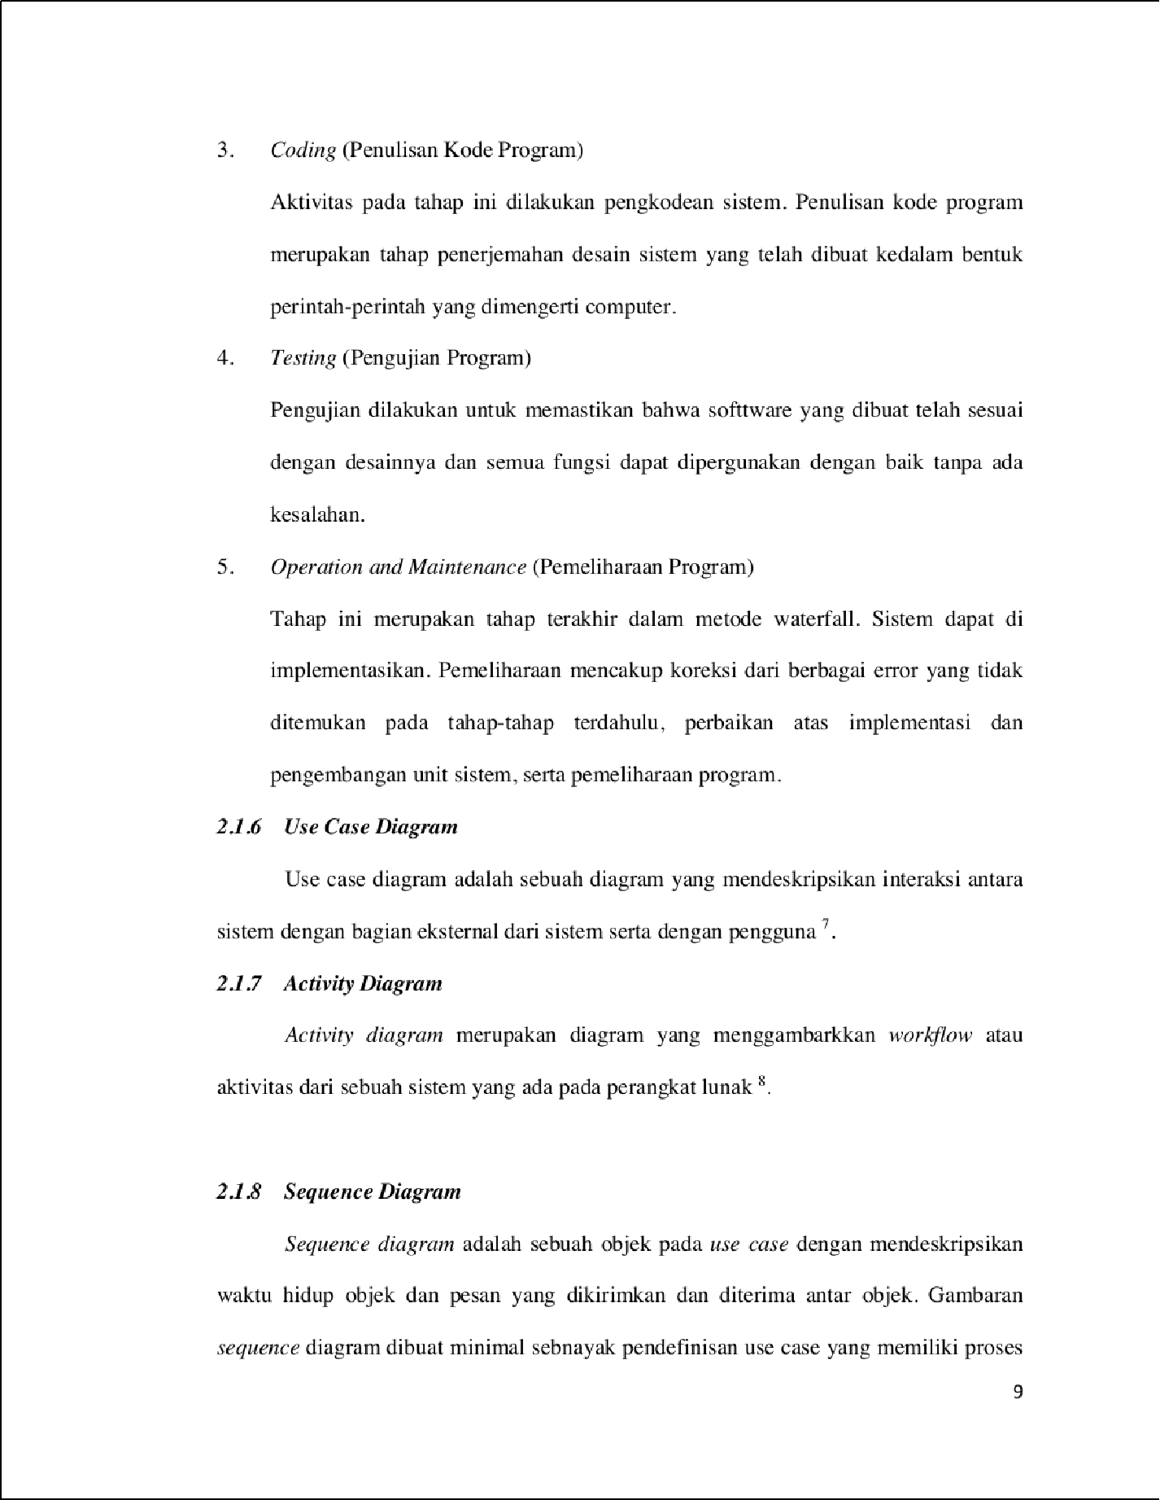

2

2

34

1

15

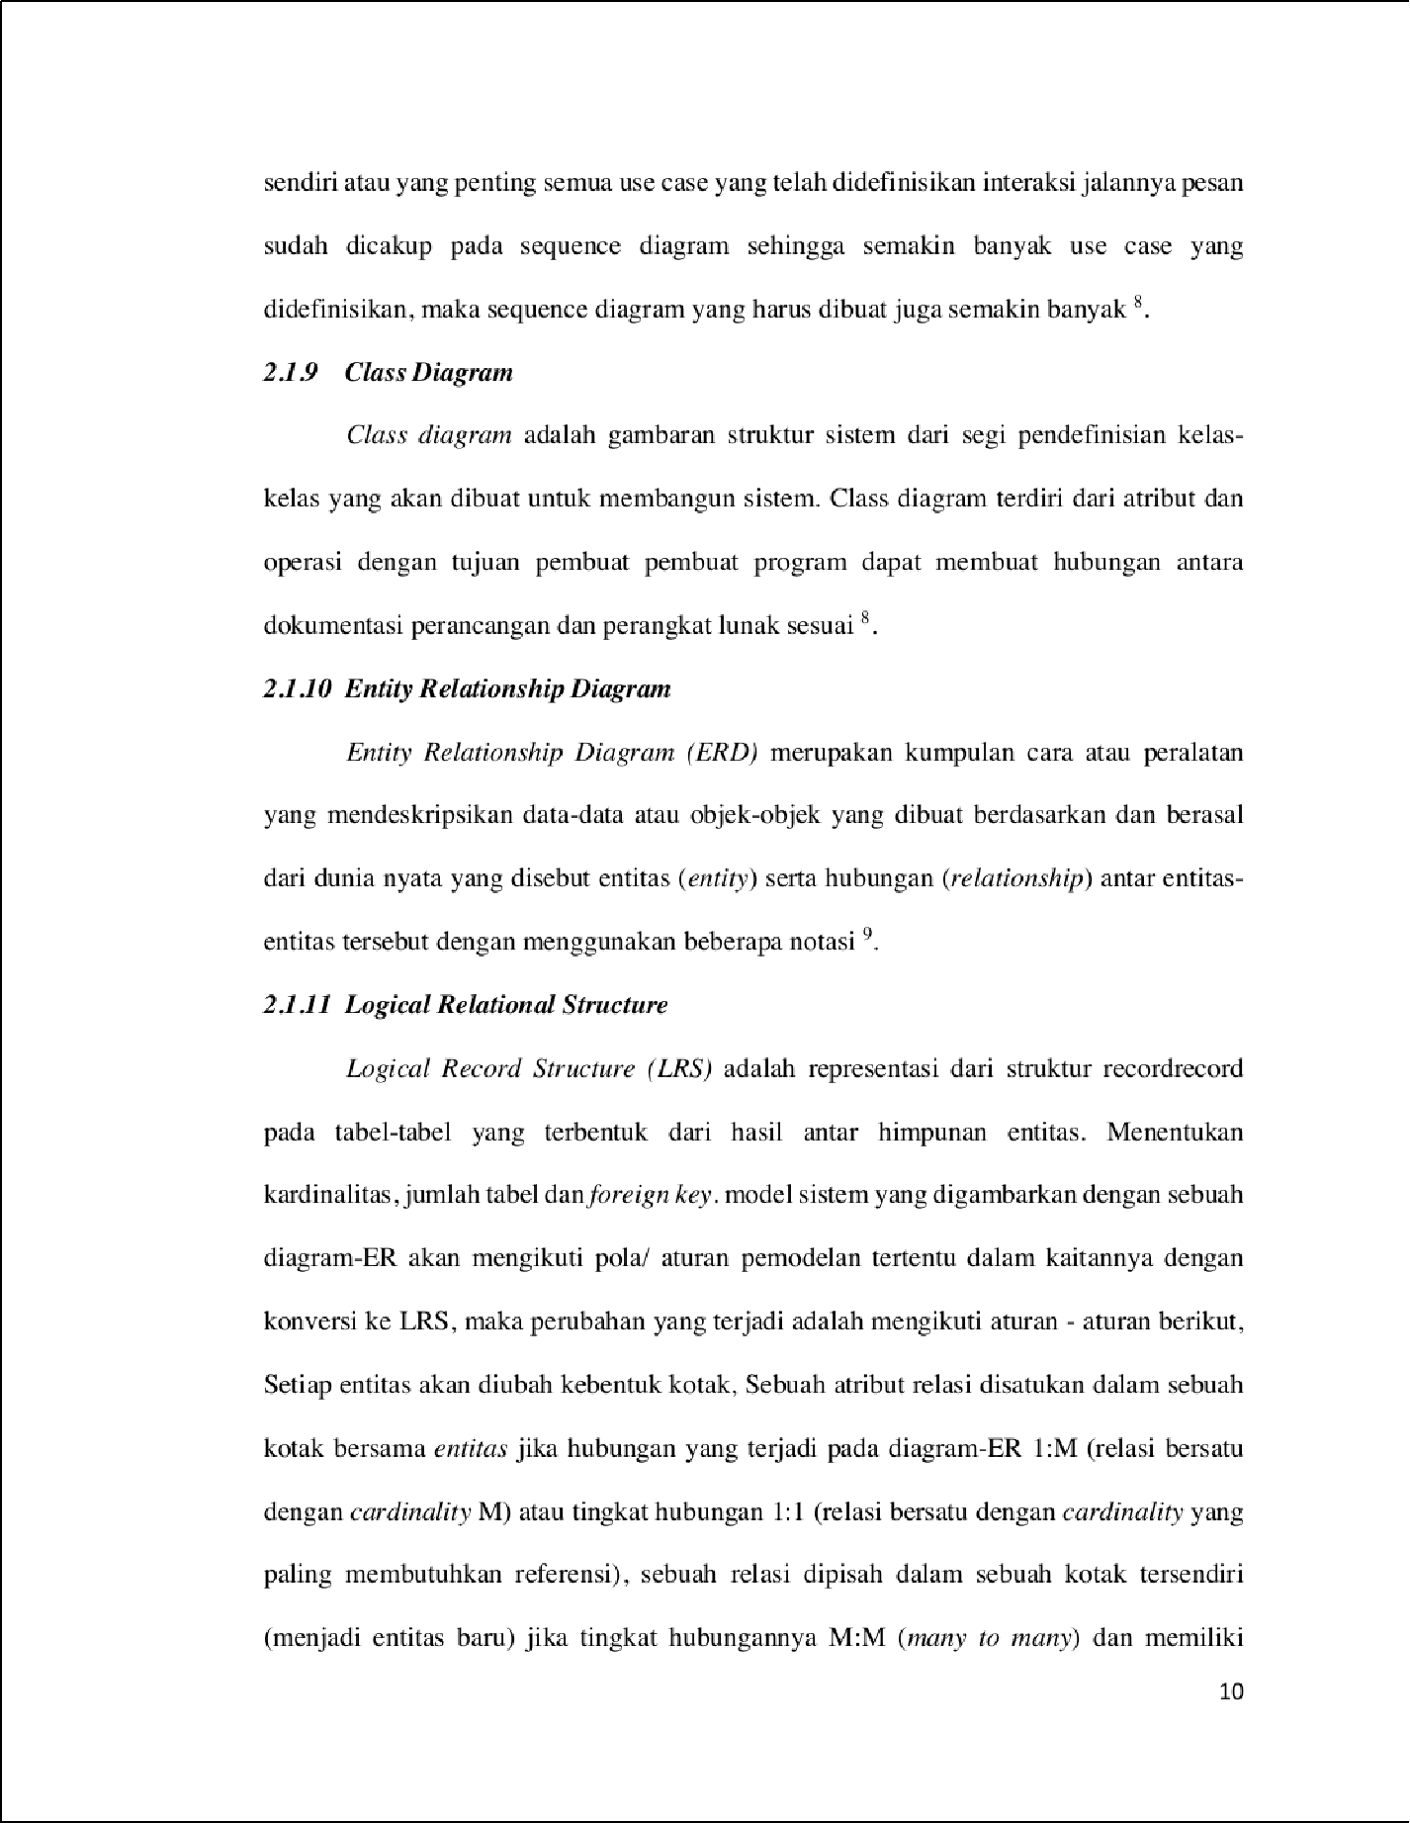

22

23

5

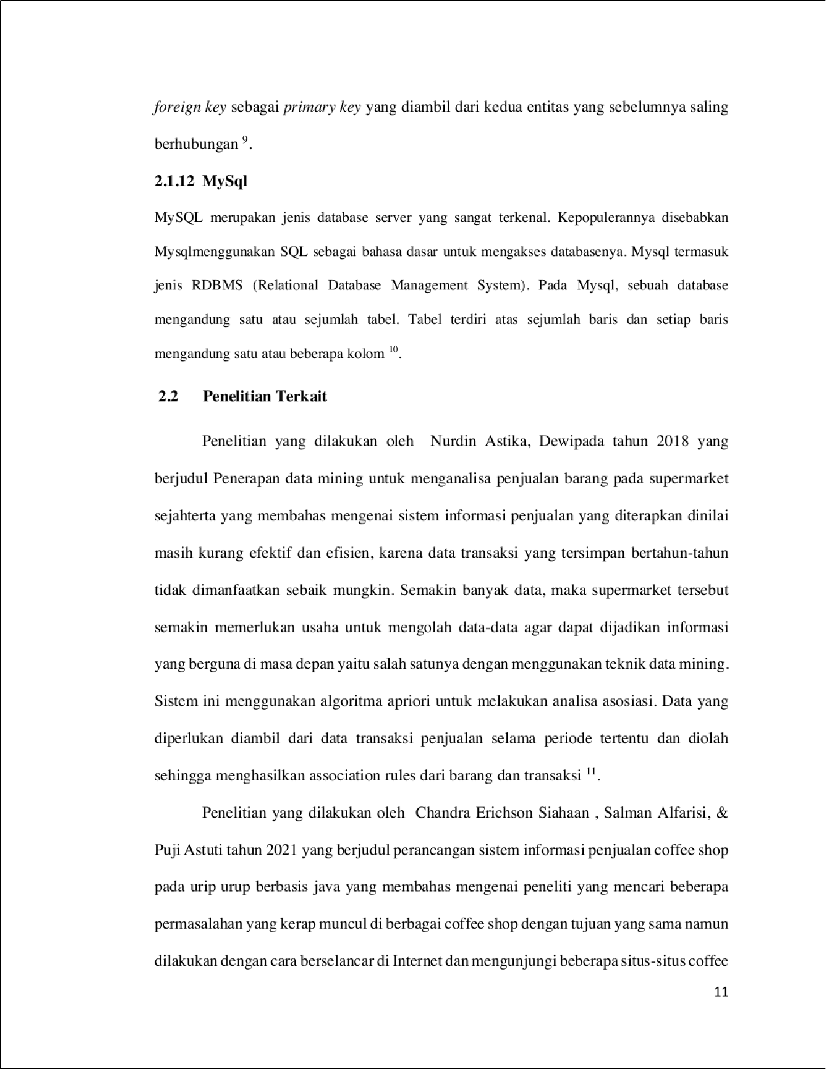

19

4

65

12

8

8

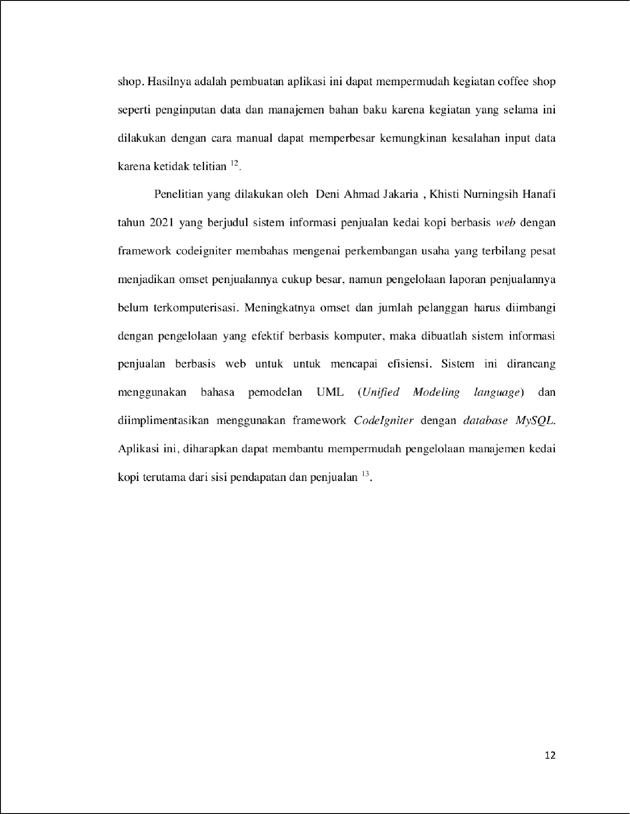

11

11

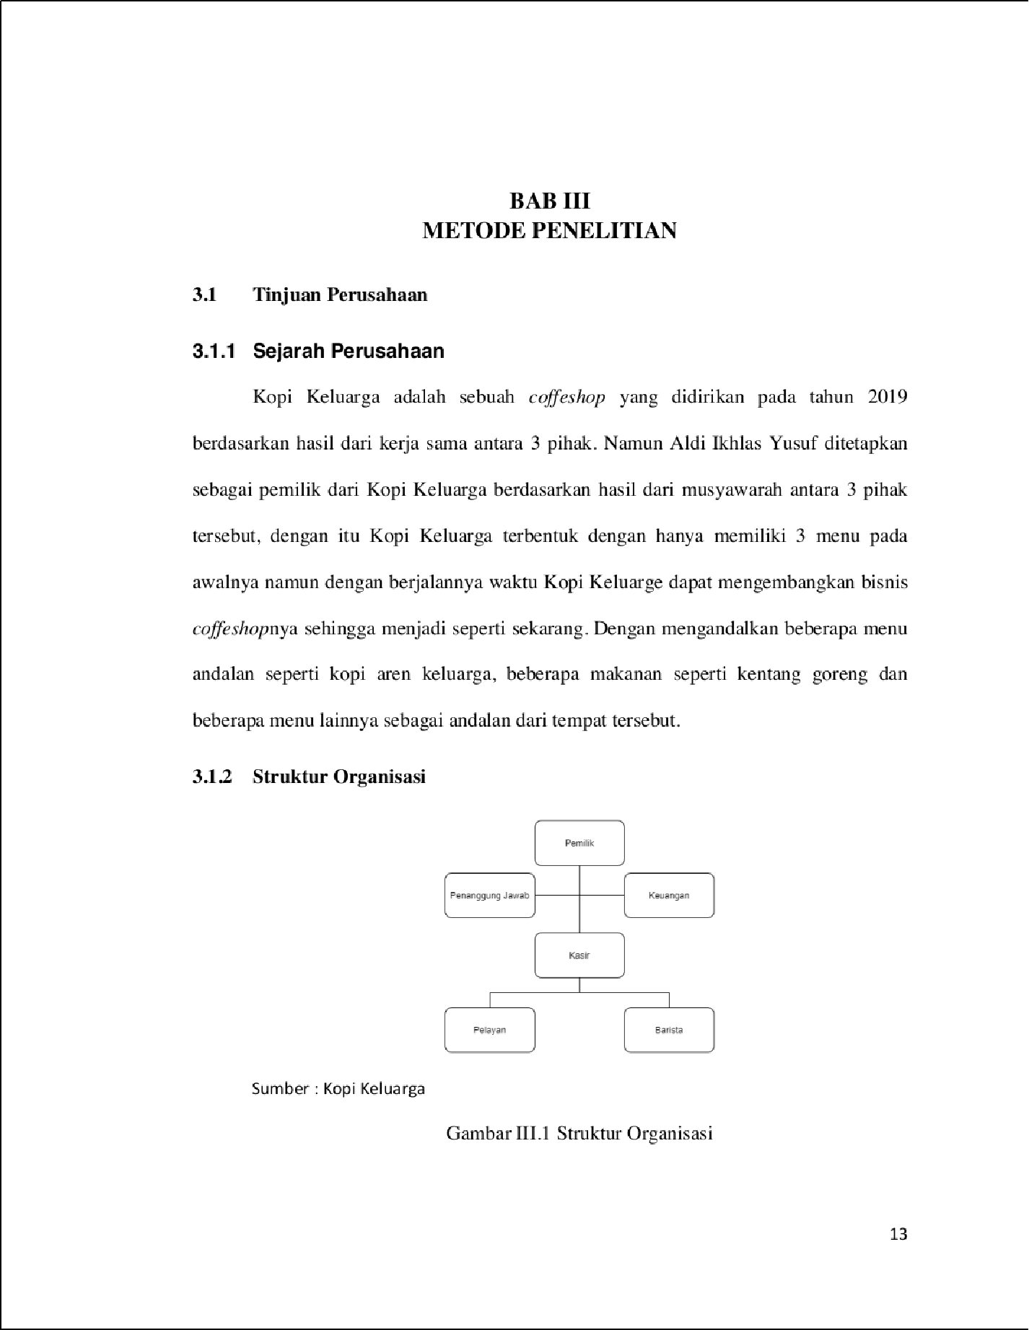

29

1

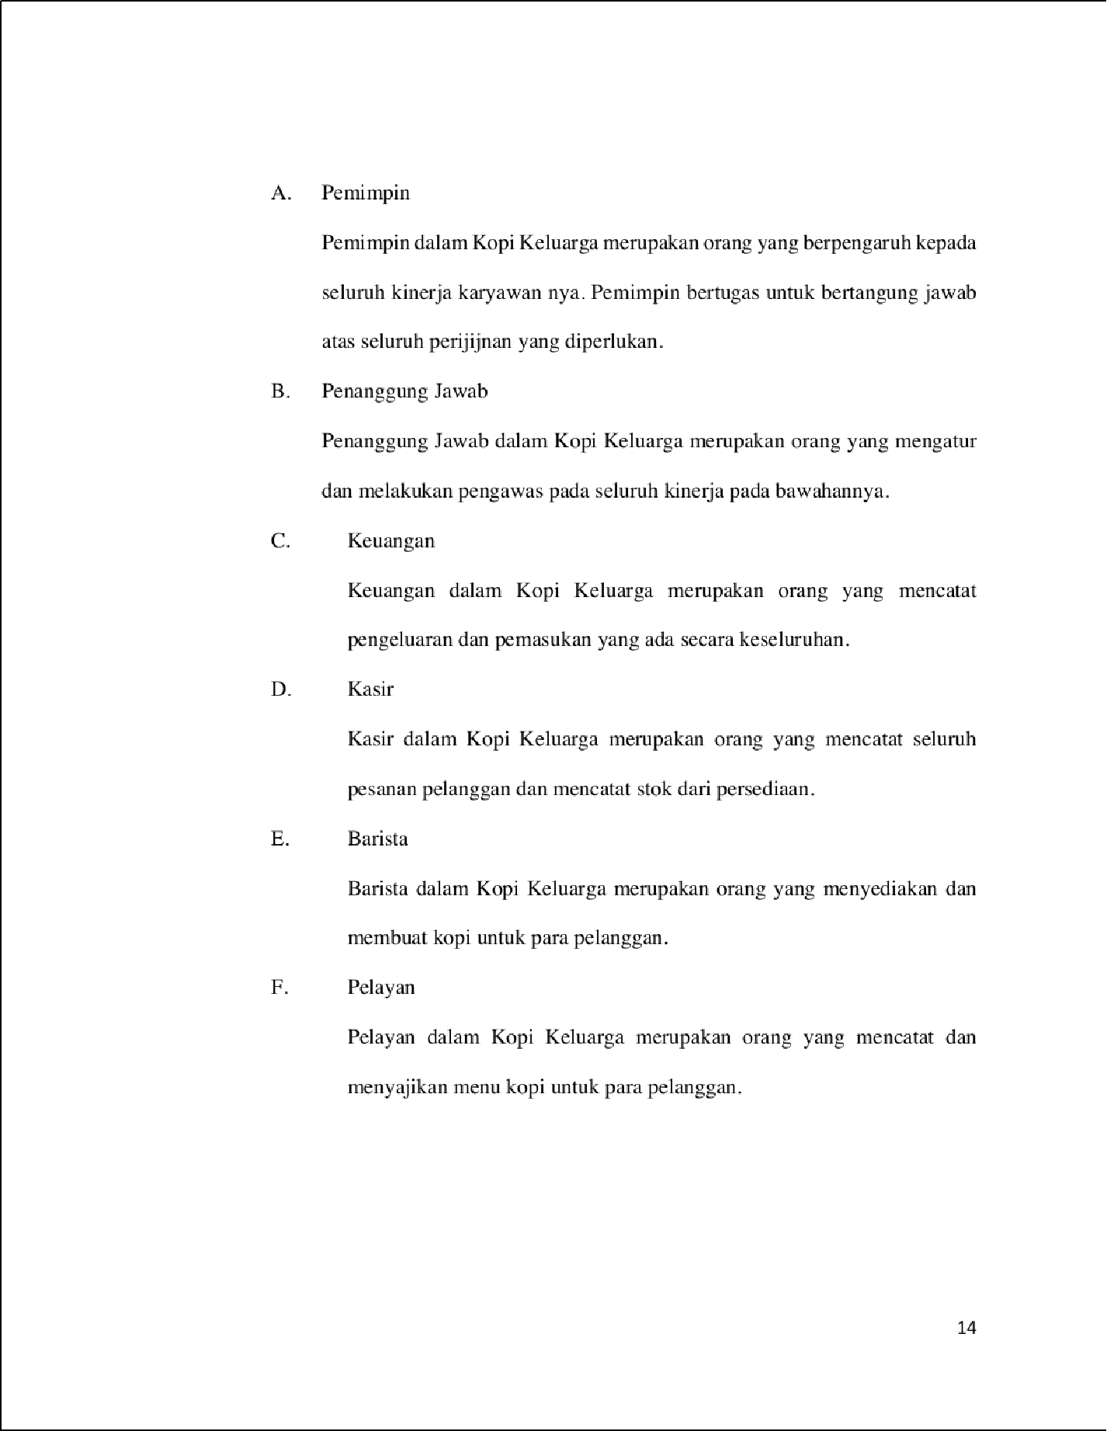

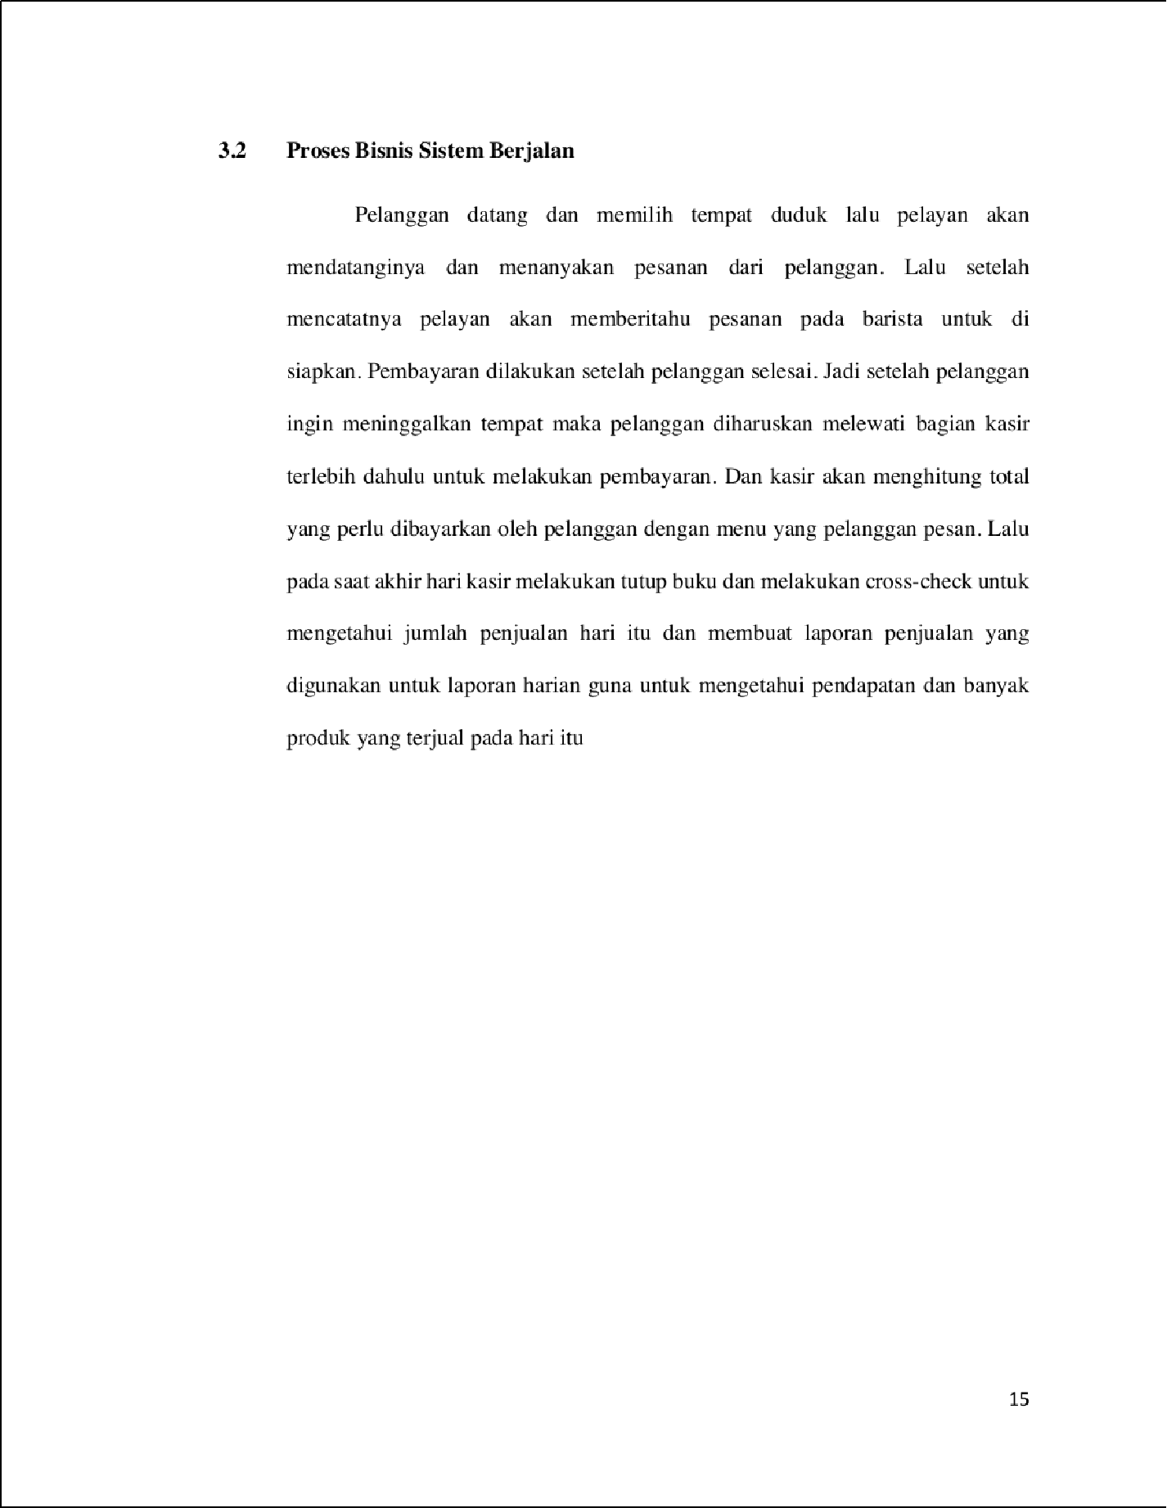

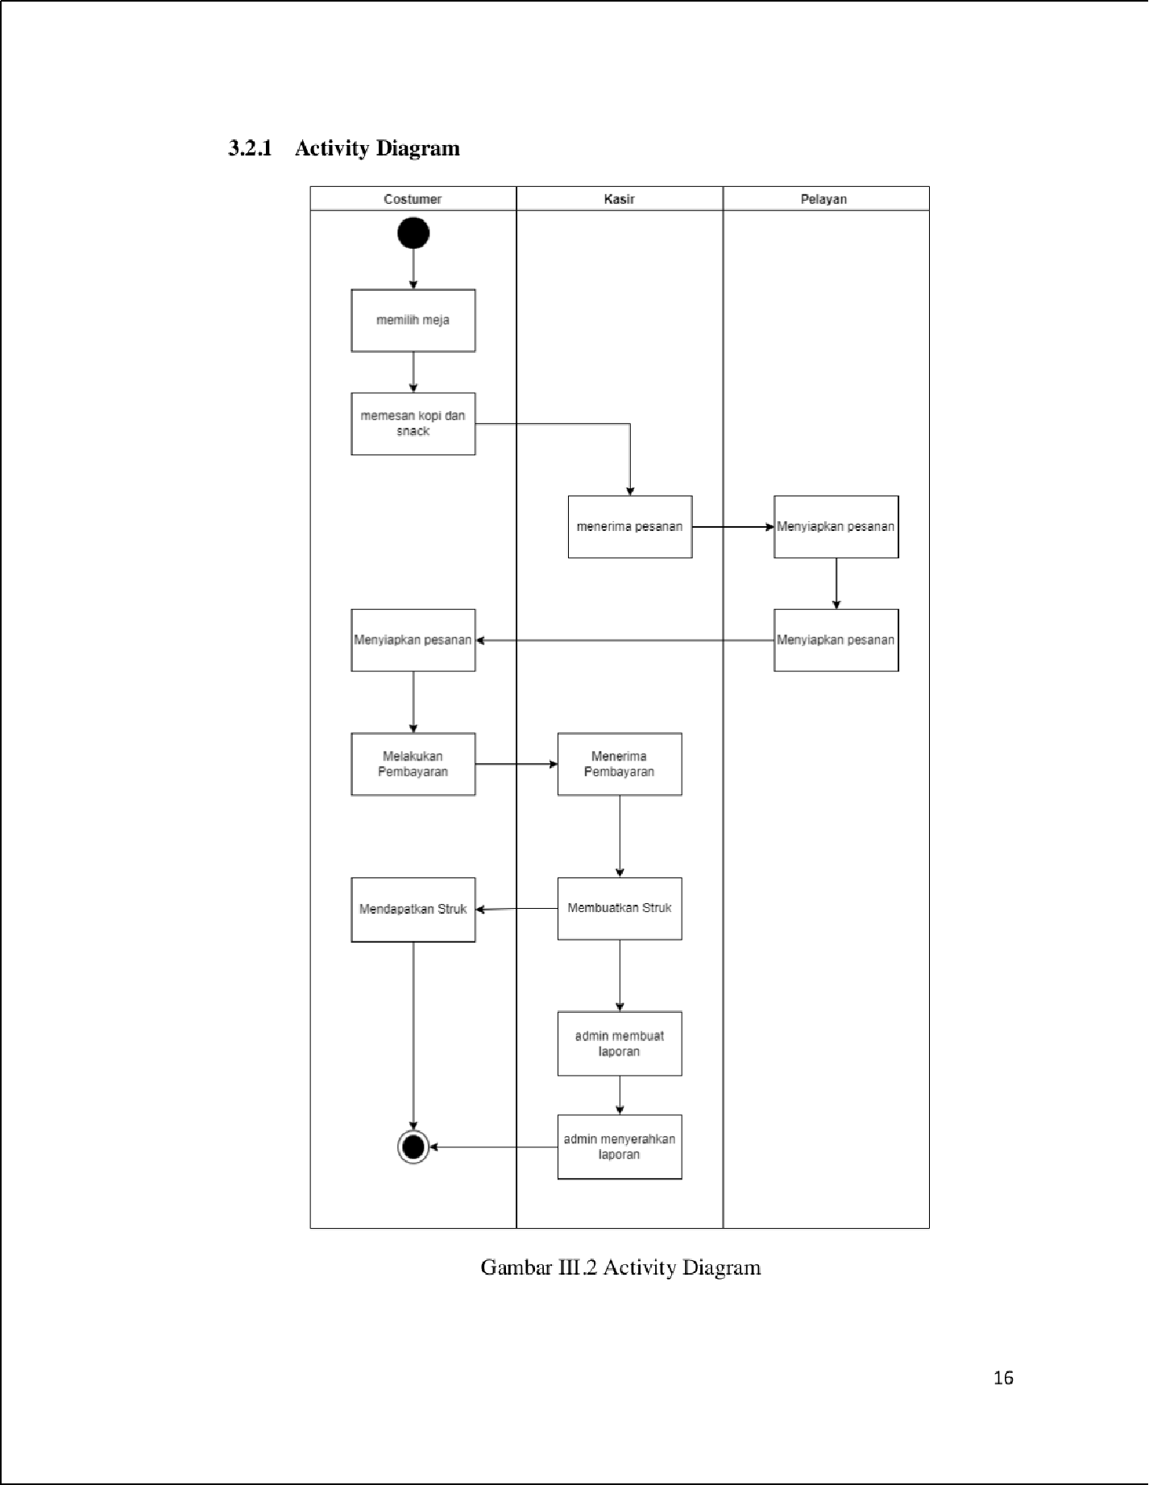

1

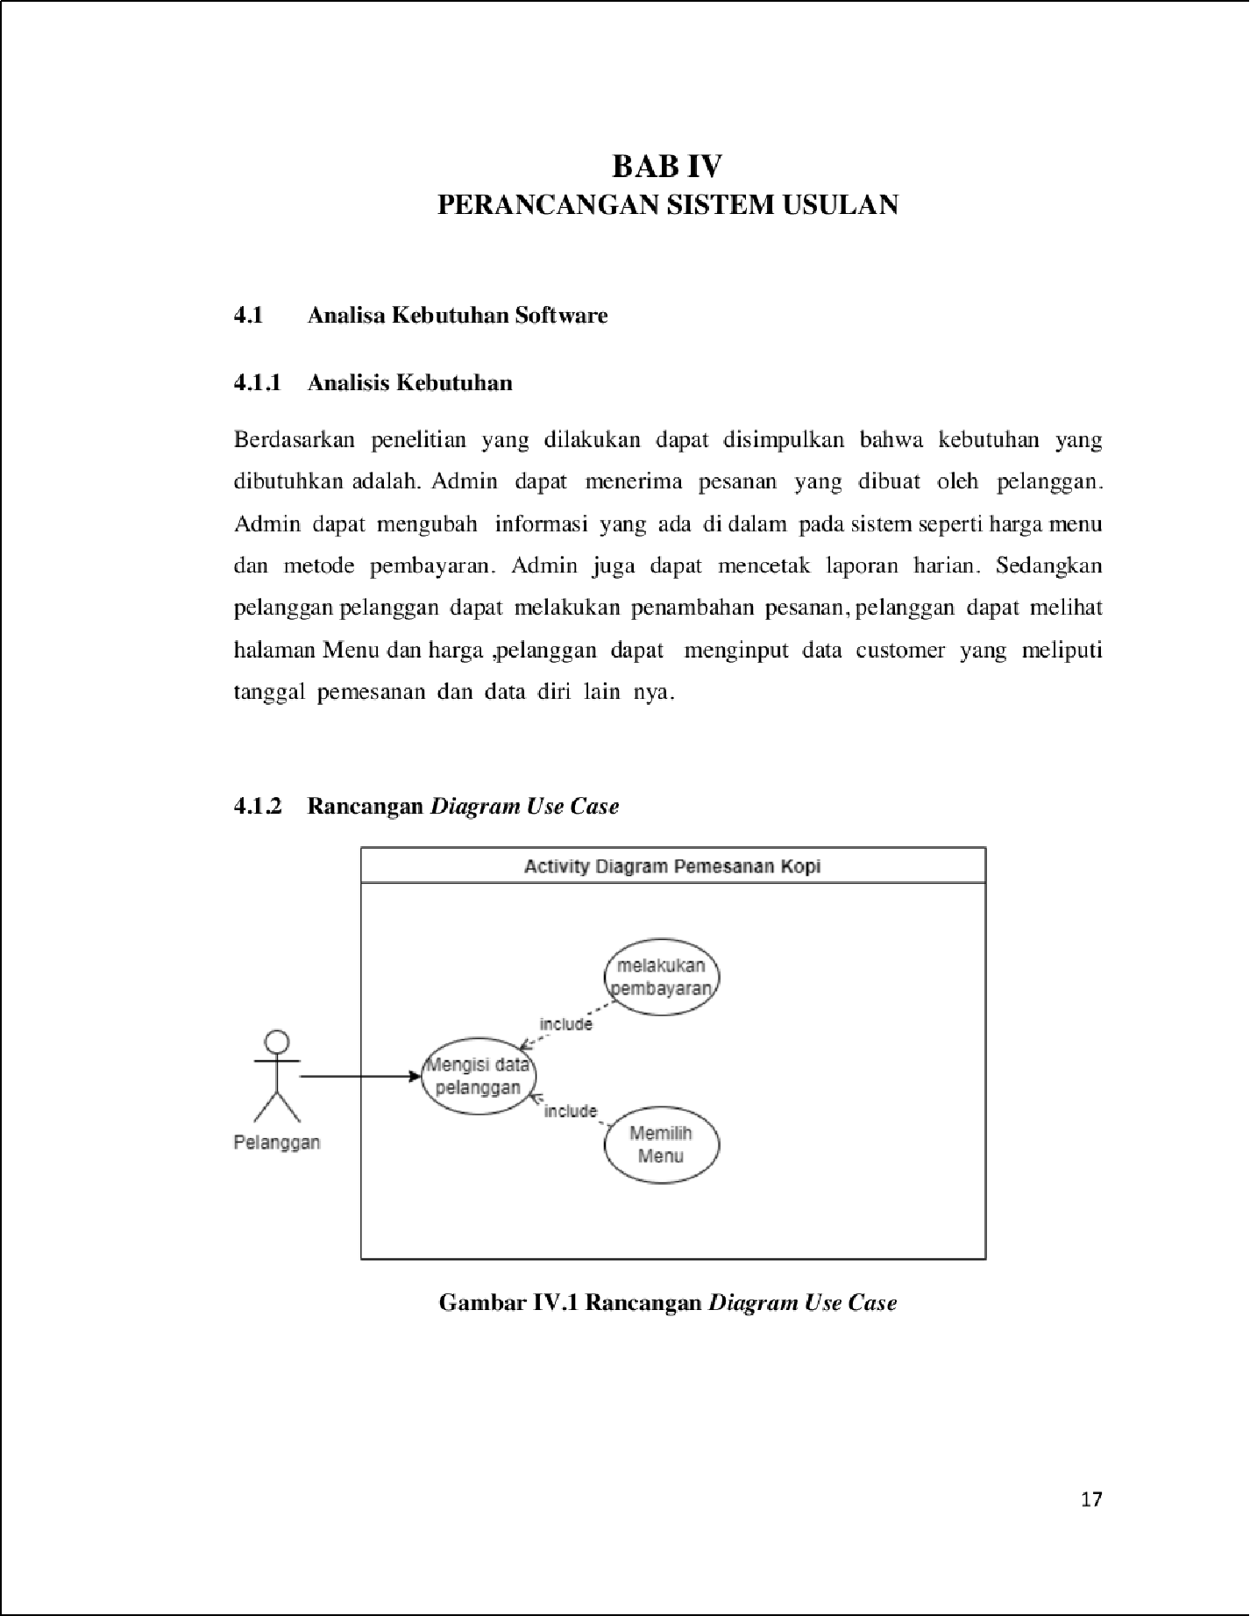

1

67

66

1

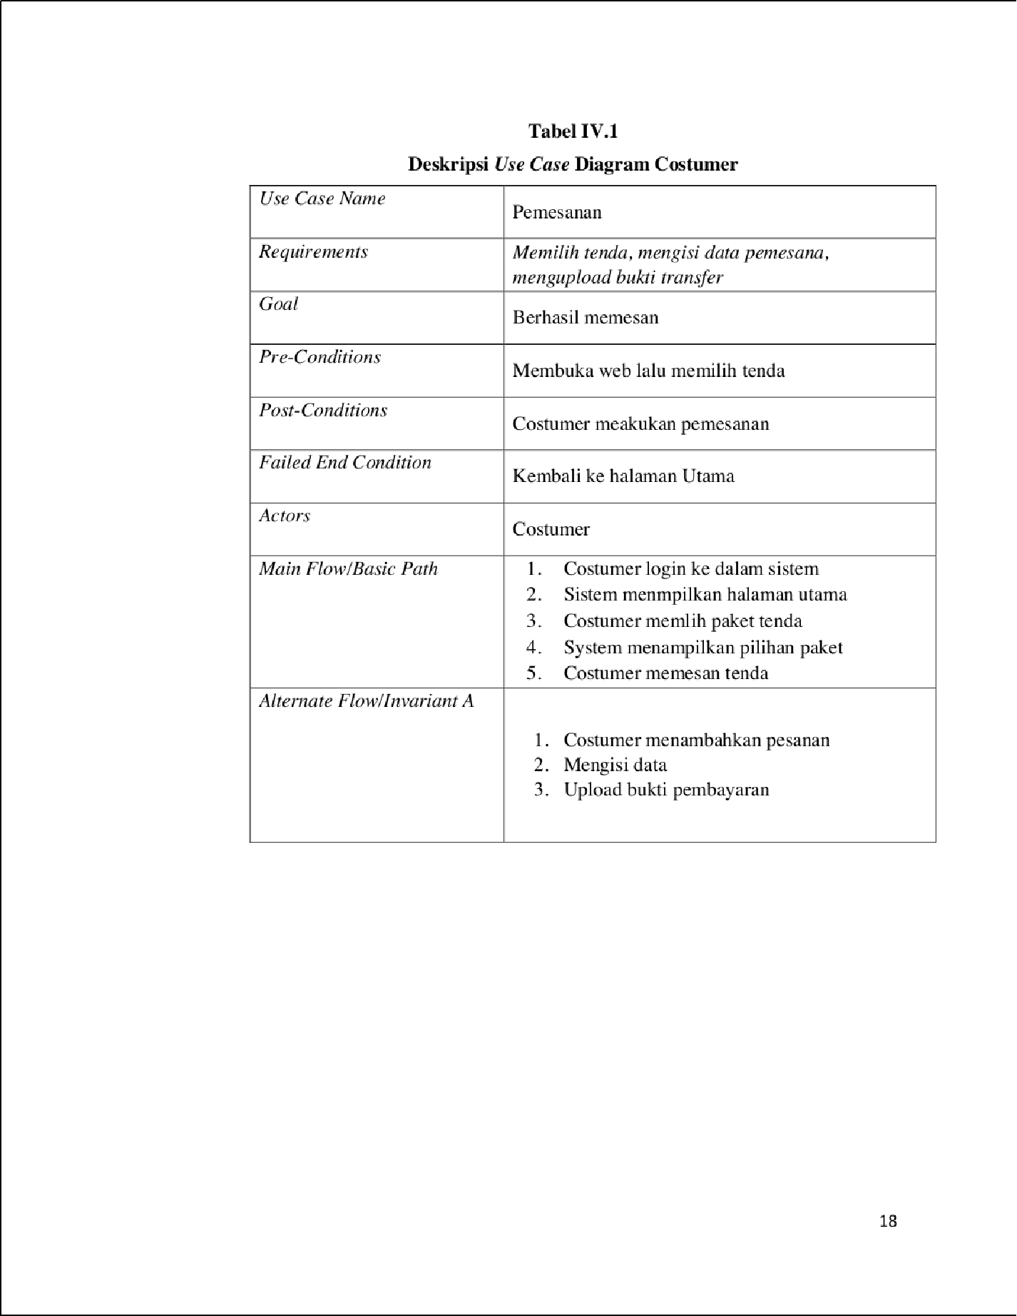

3

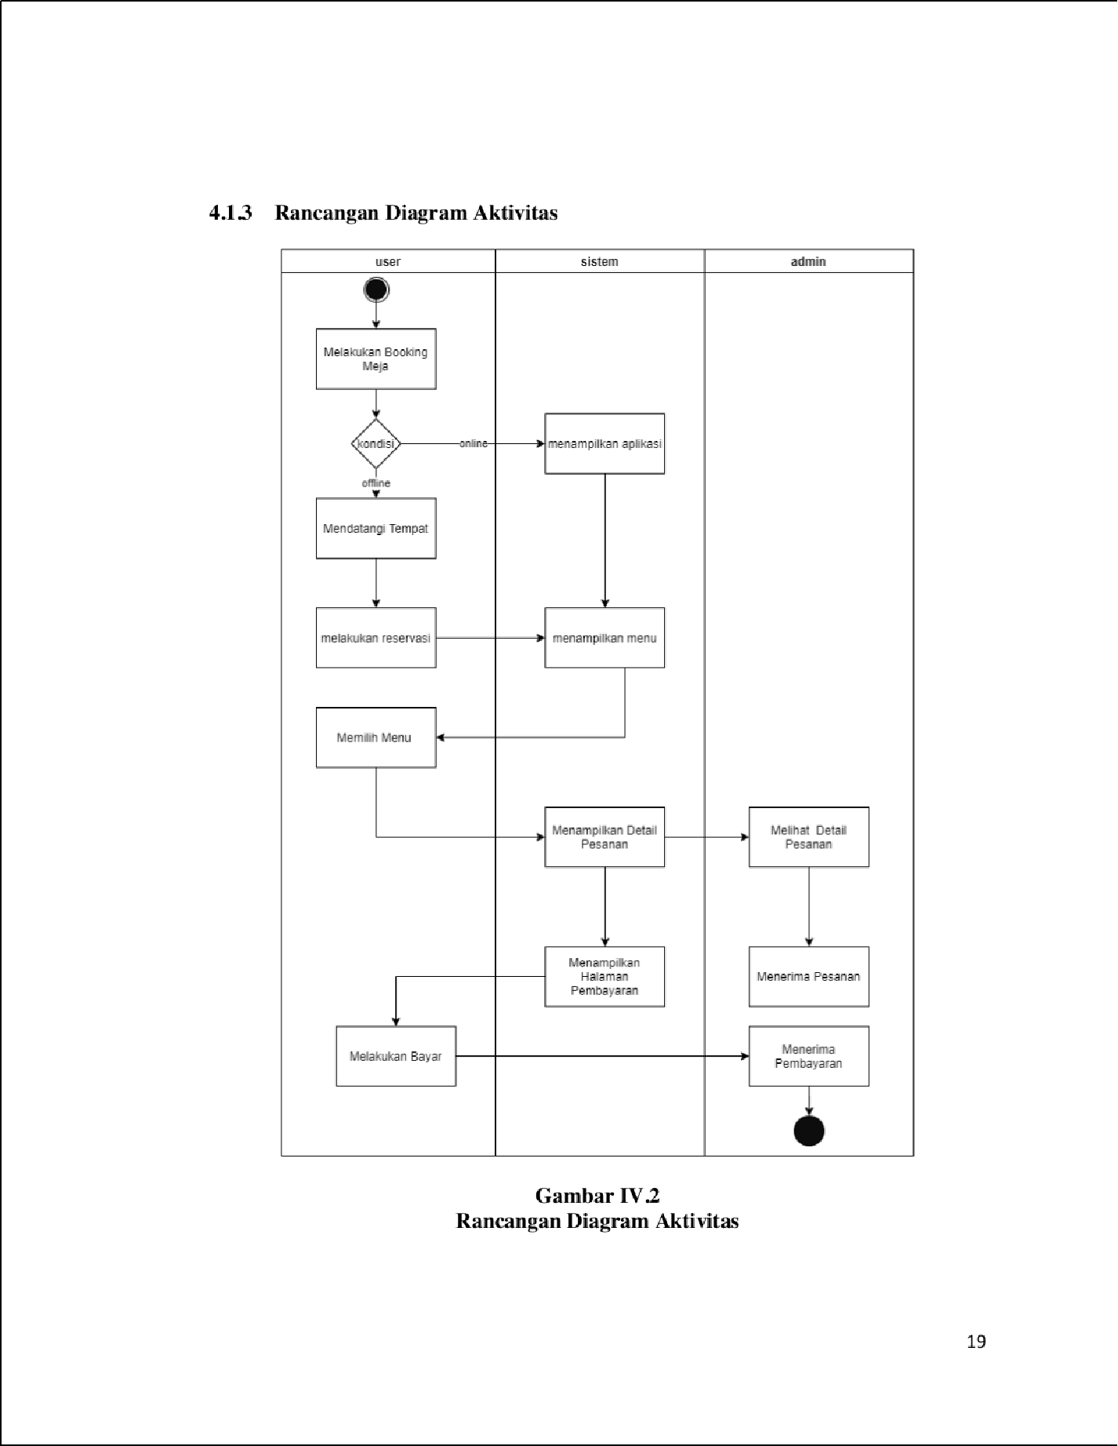

1

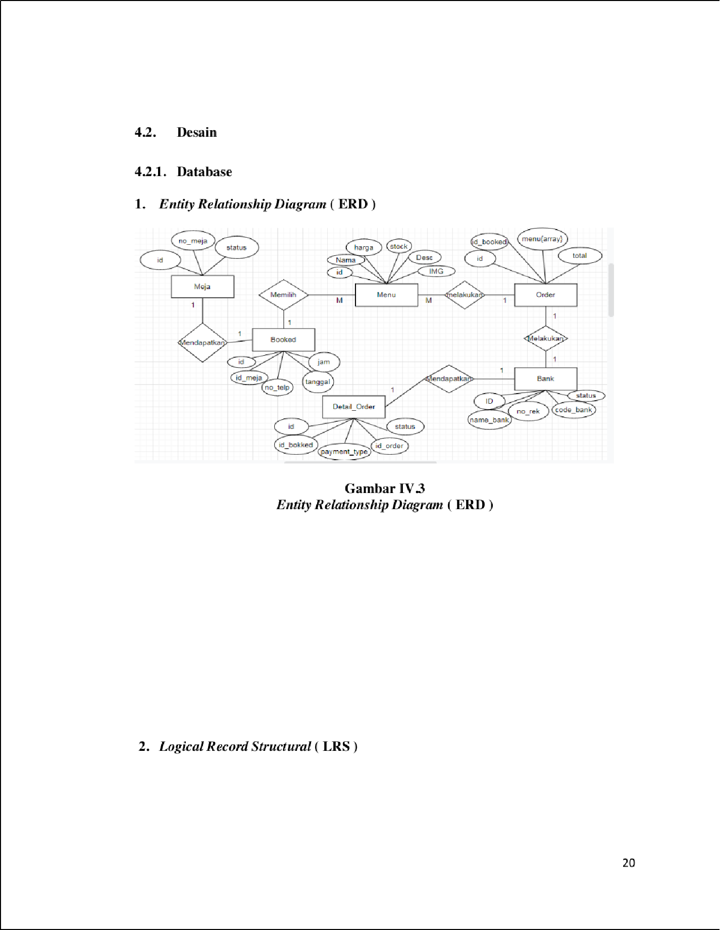

20

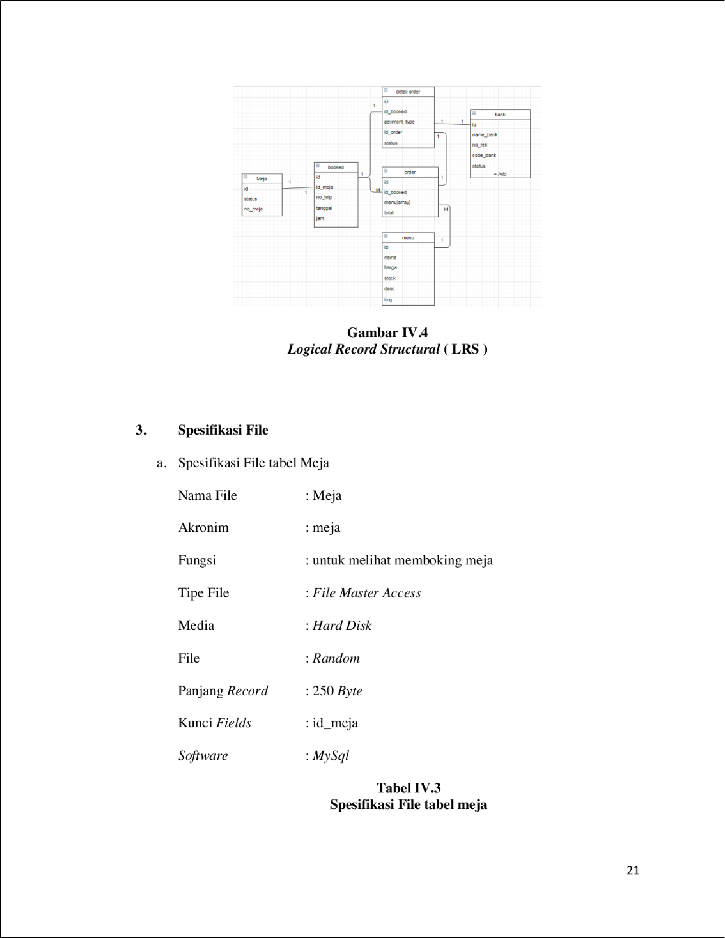

36

3

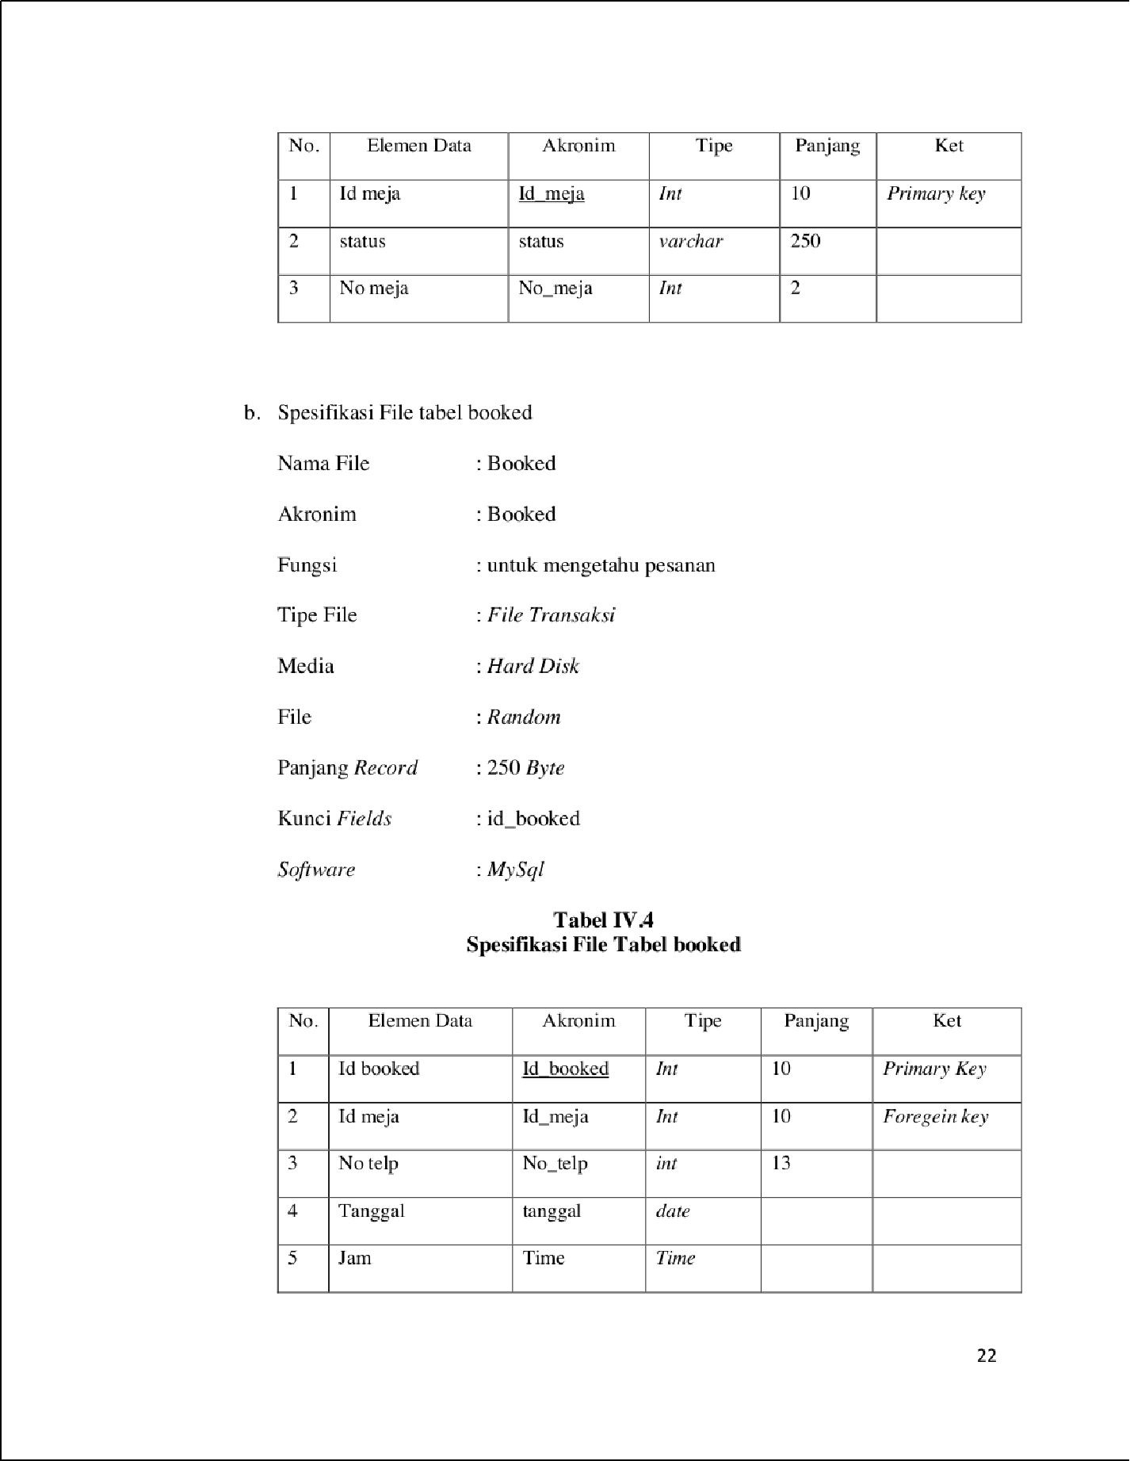

4

3

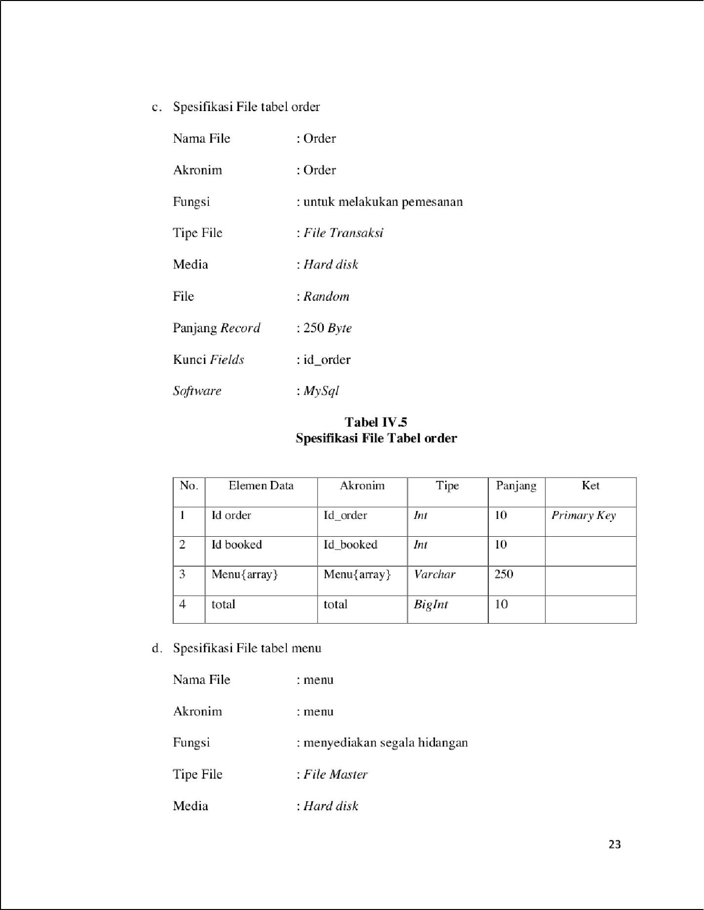

1

3

36

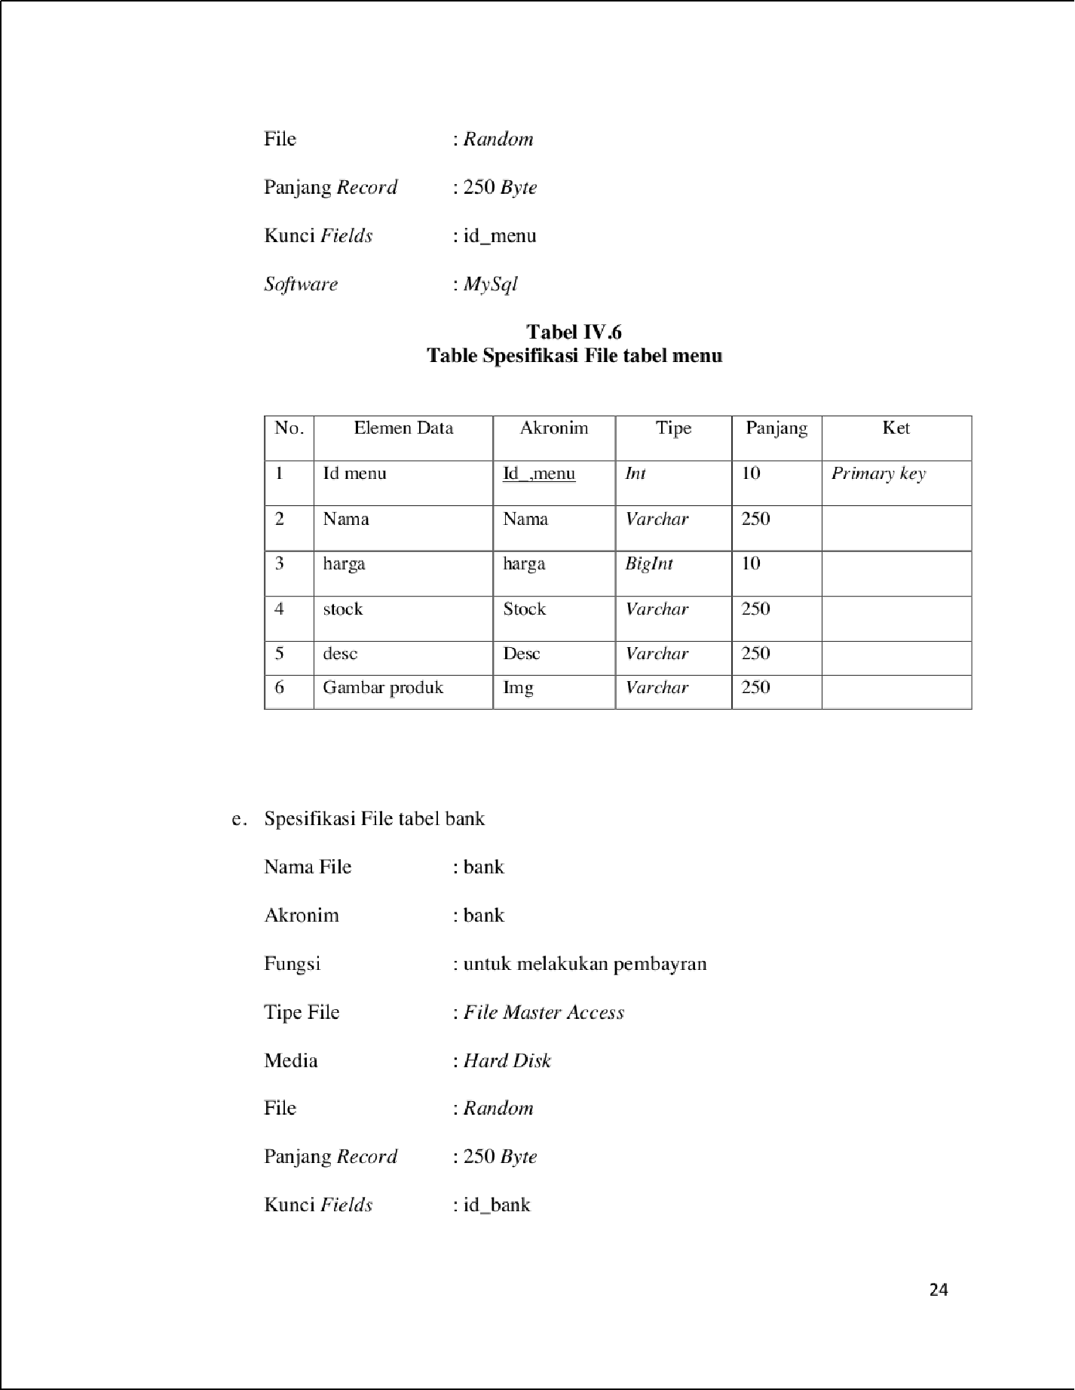

1

18

18

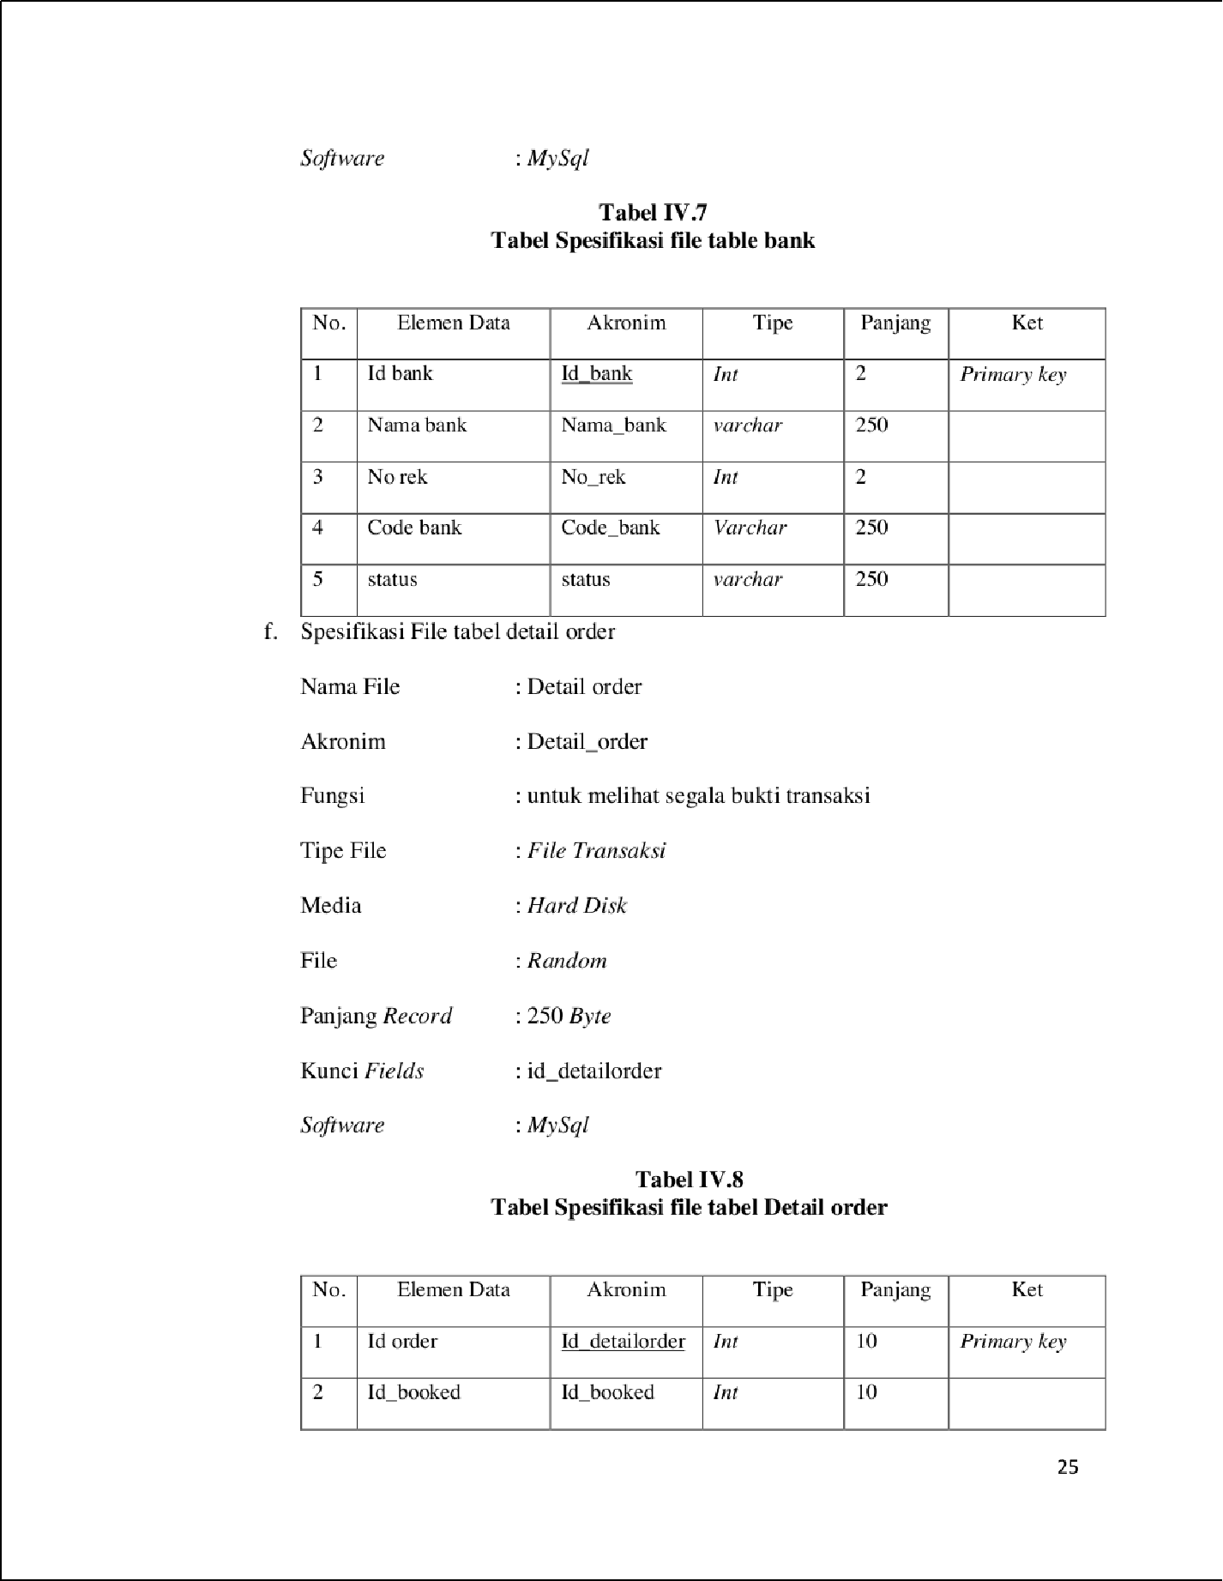

1

3

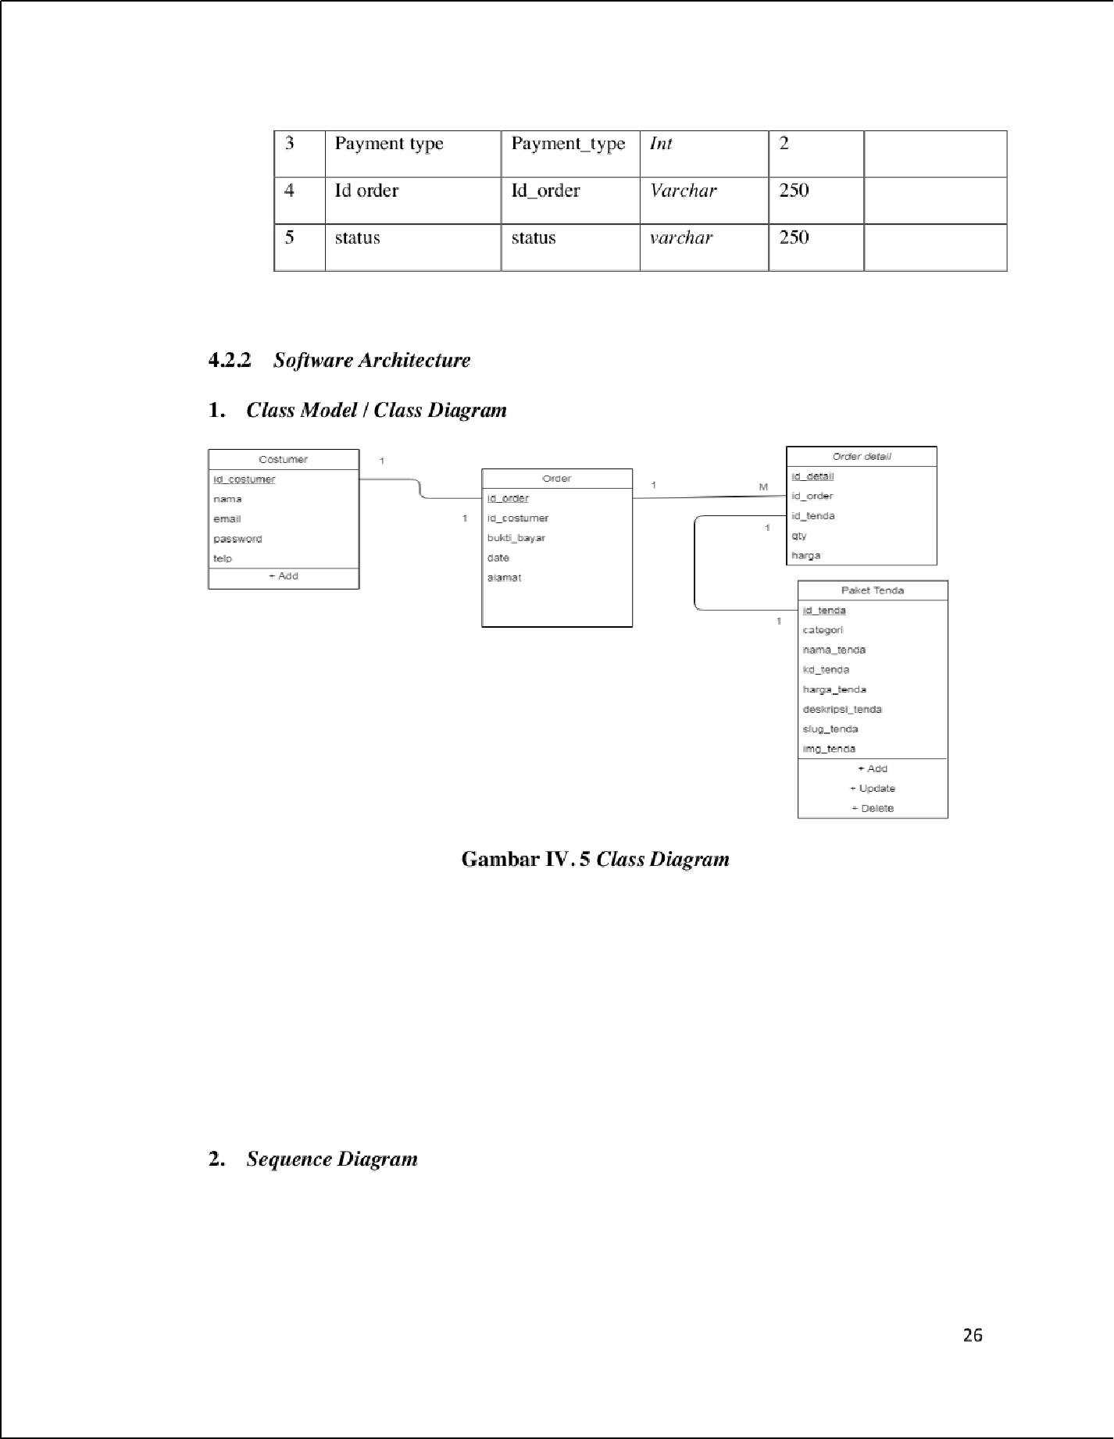

1

1

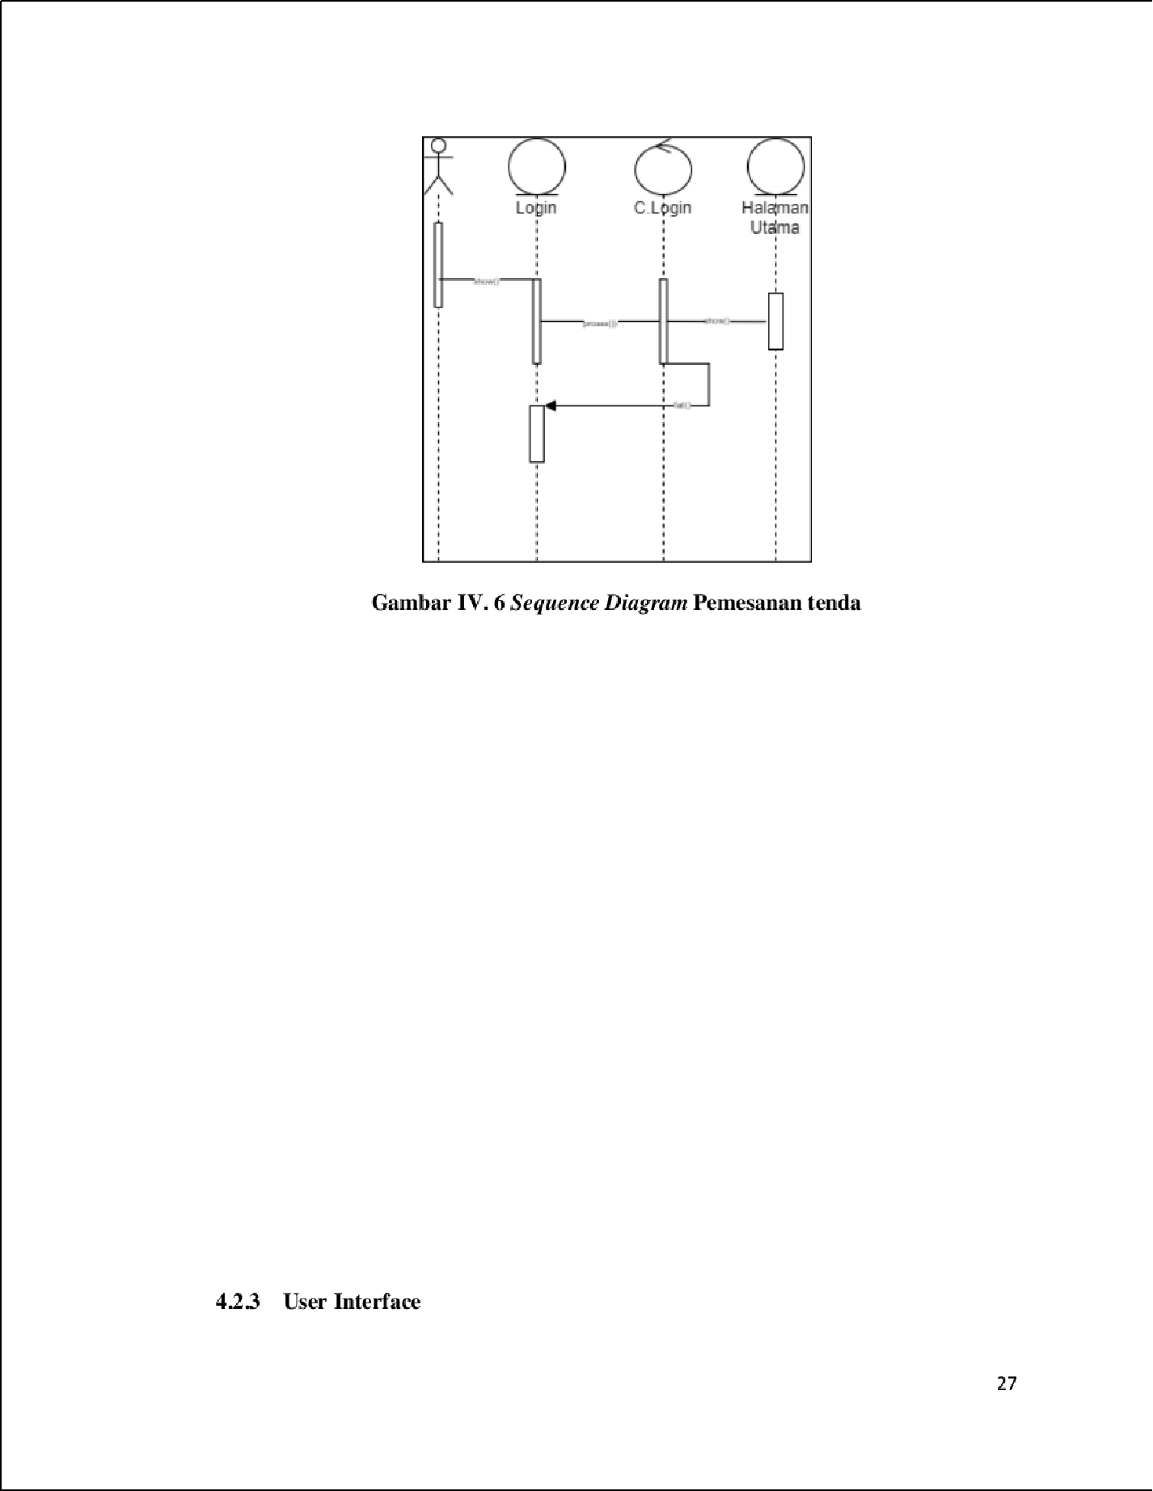

1

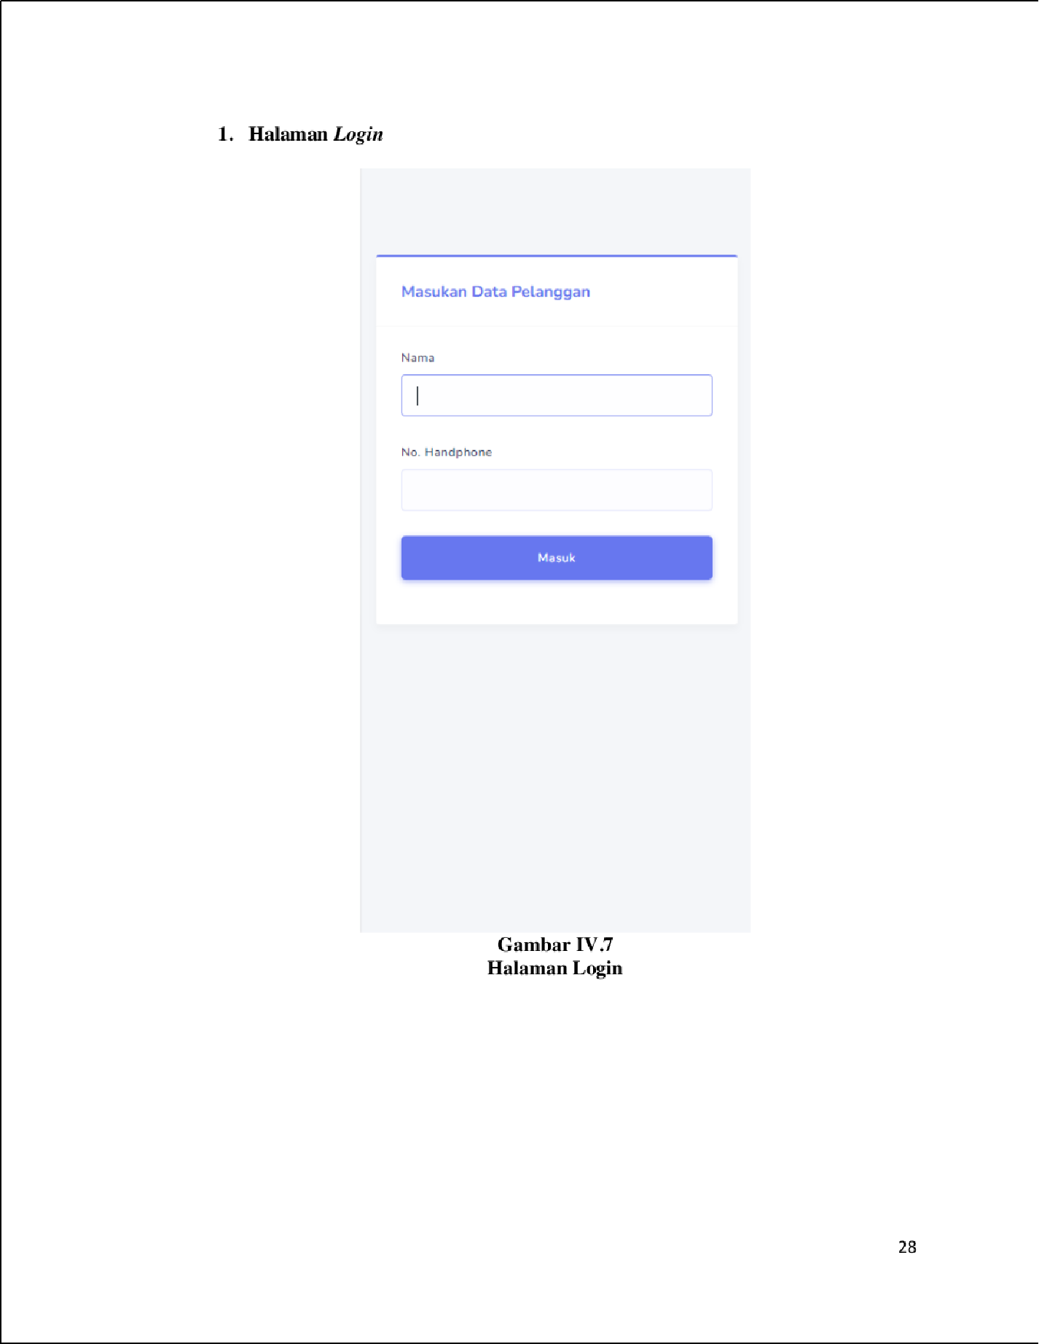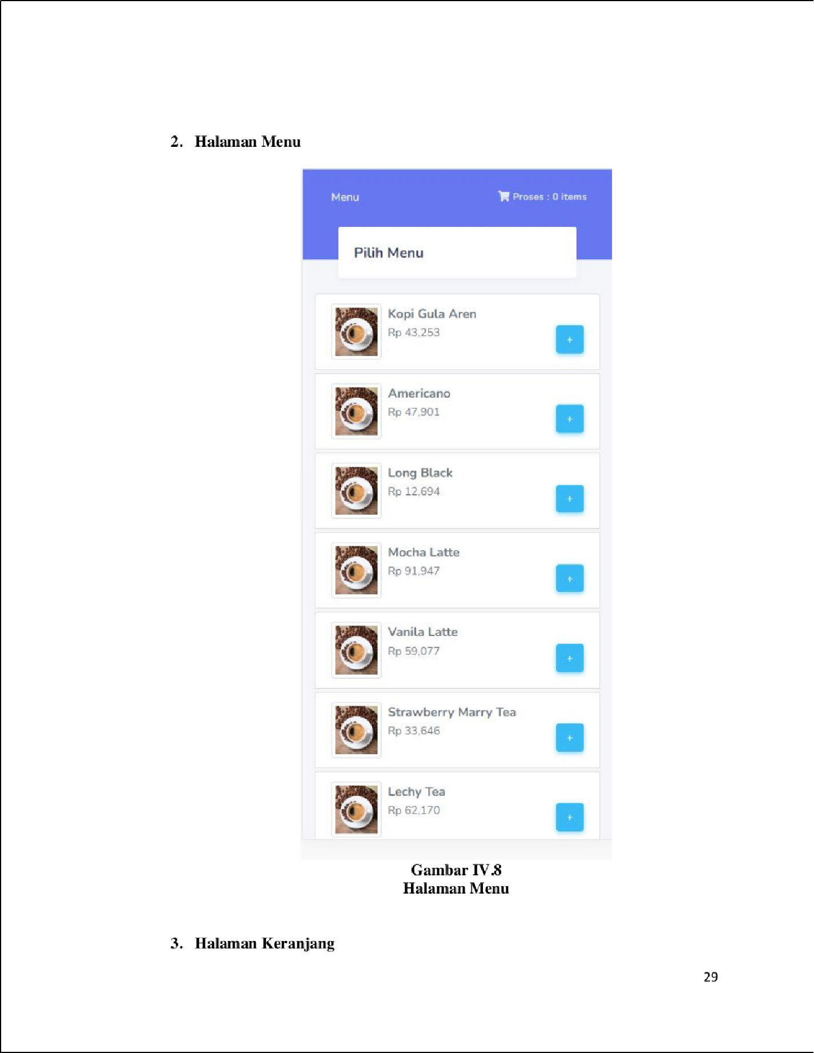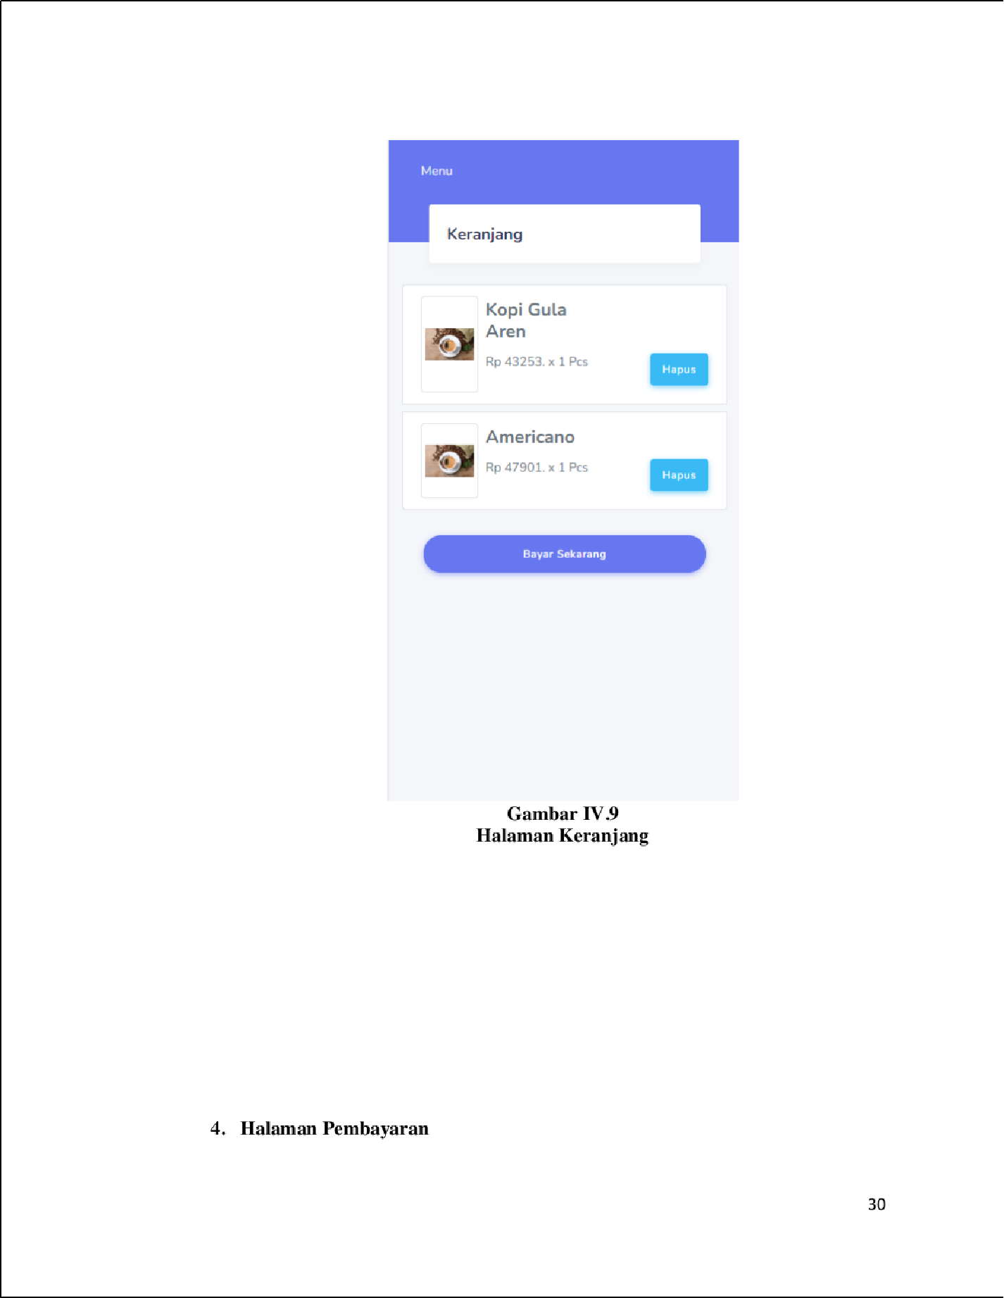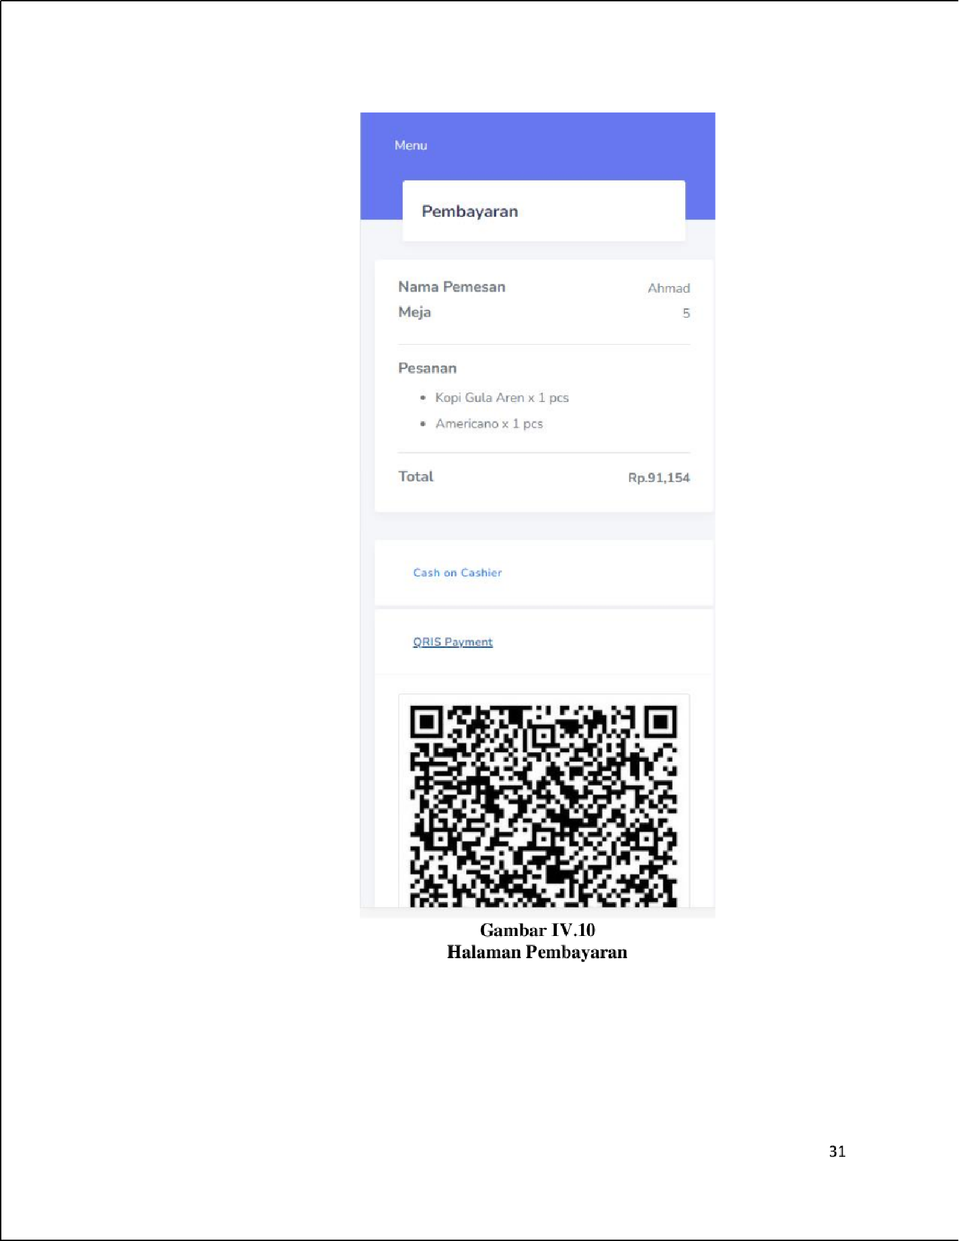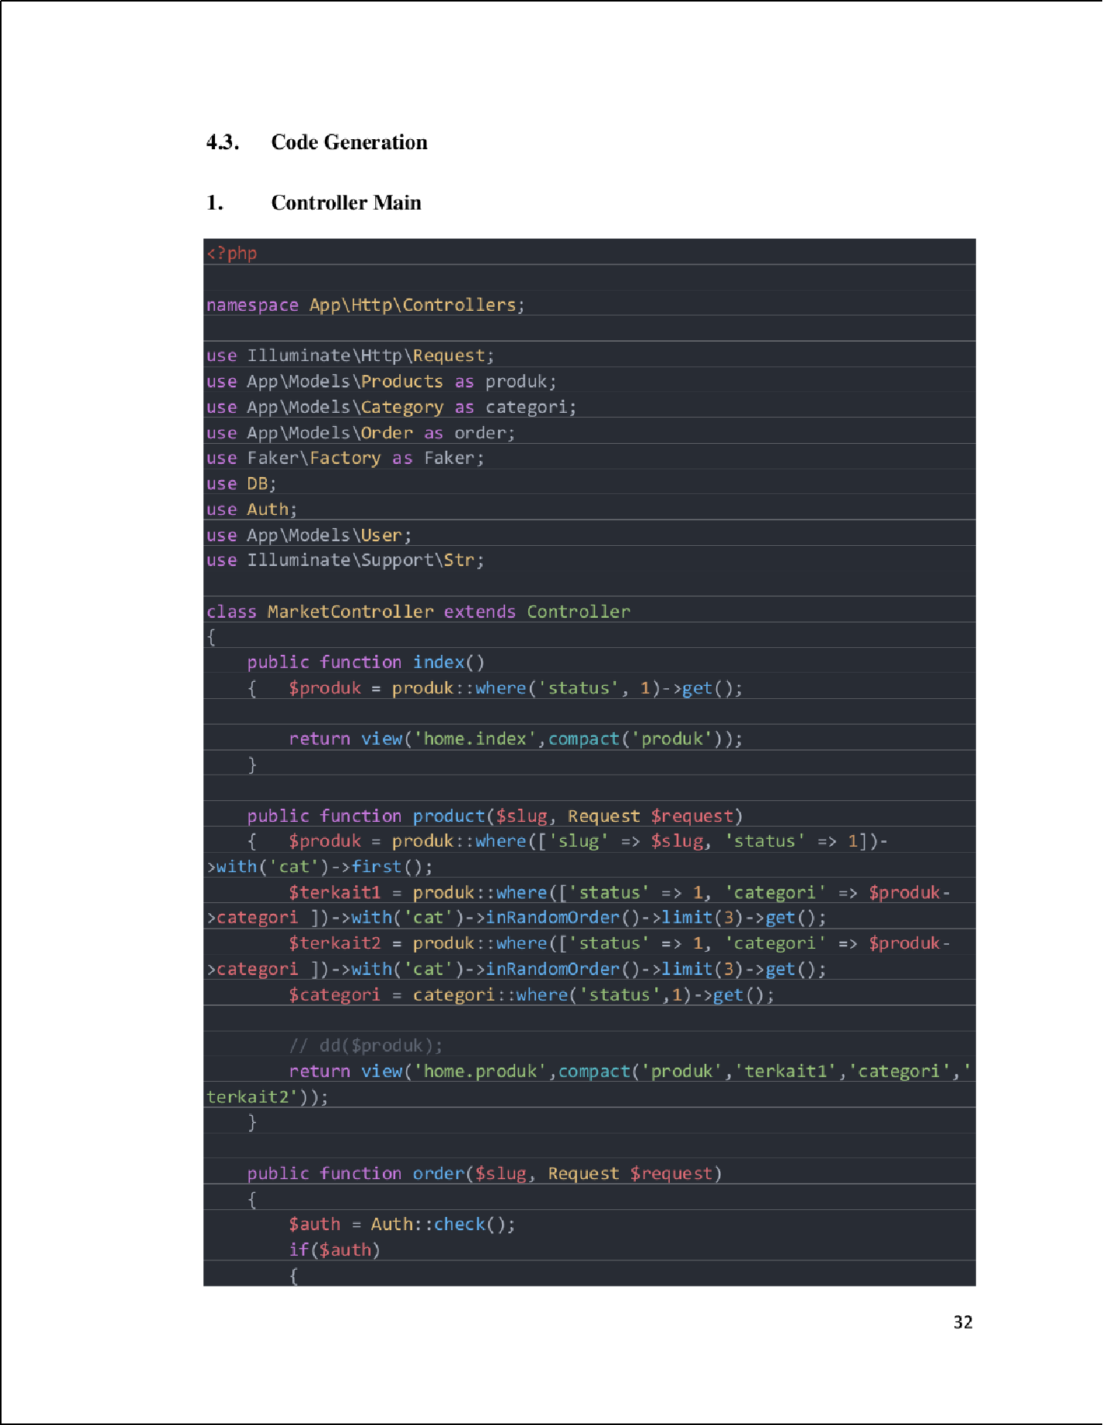

14

14

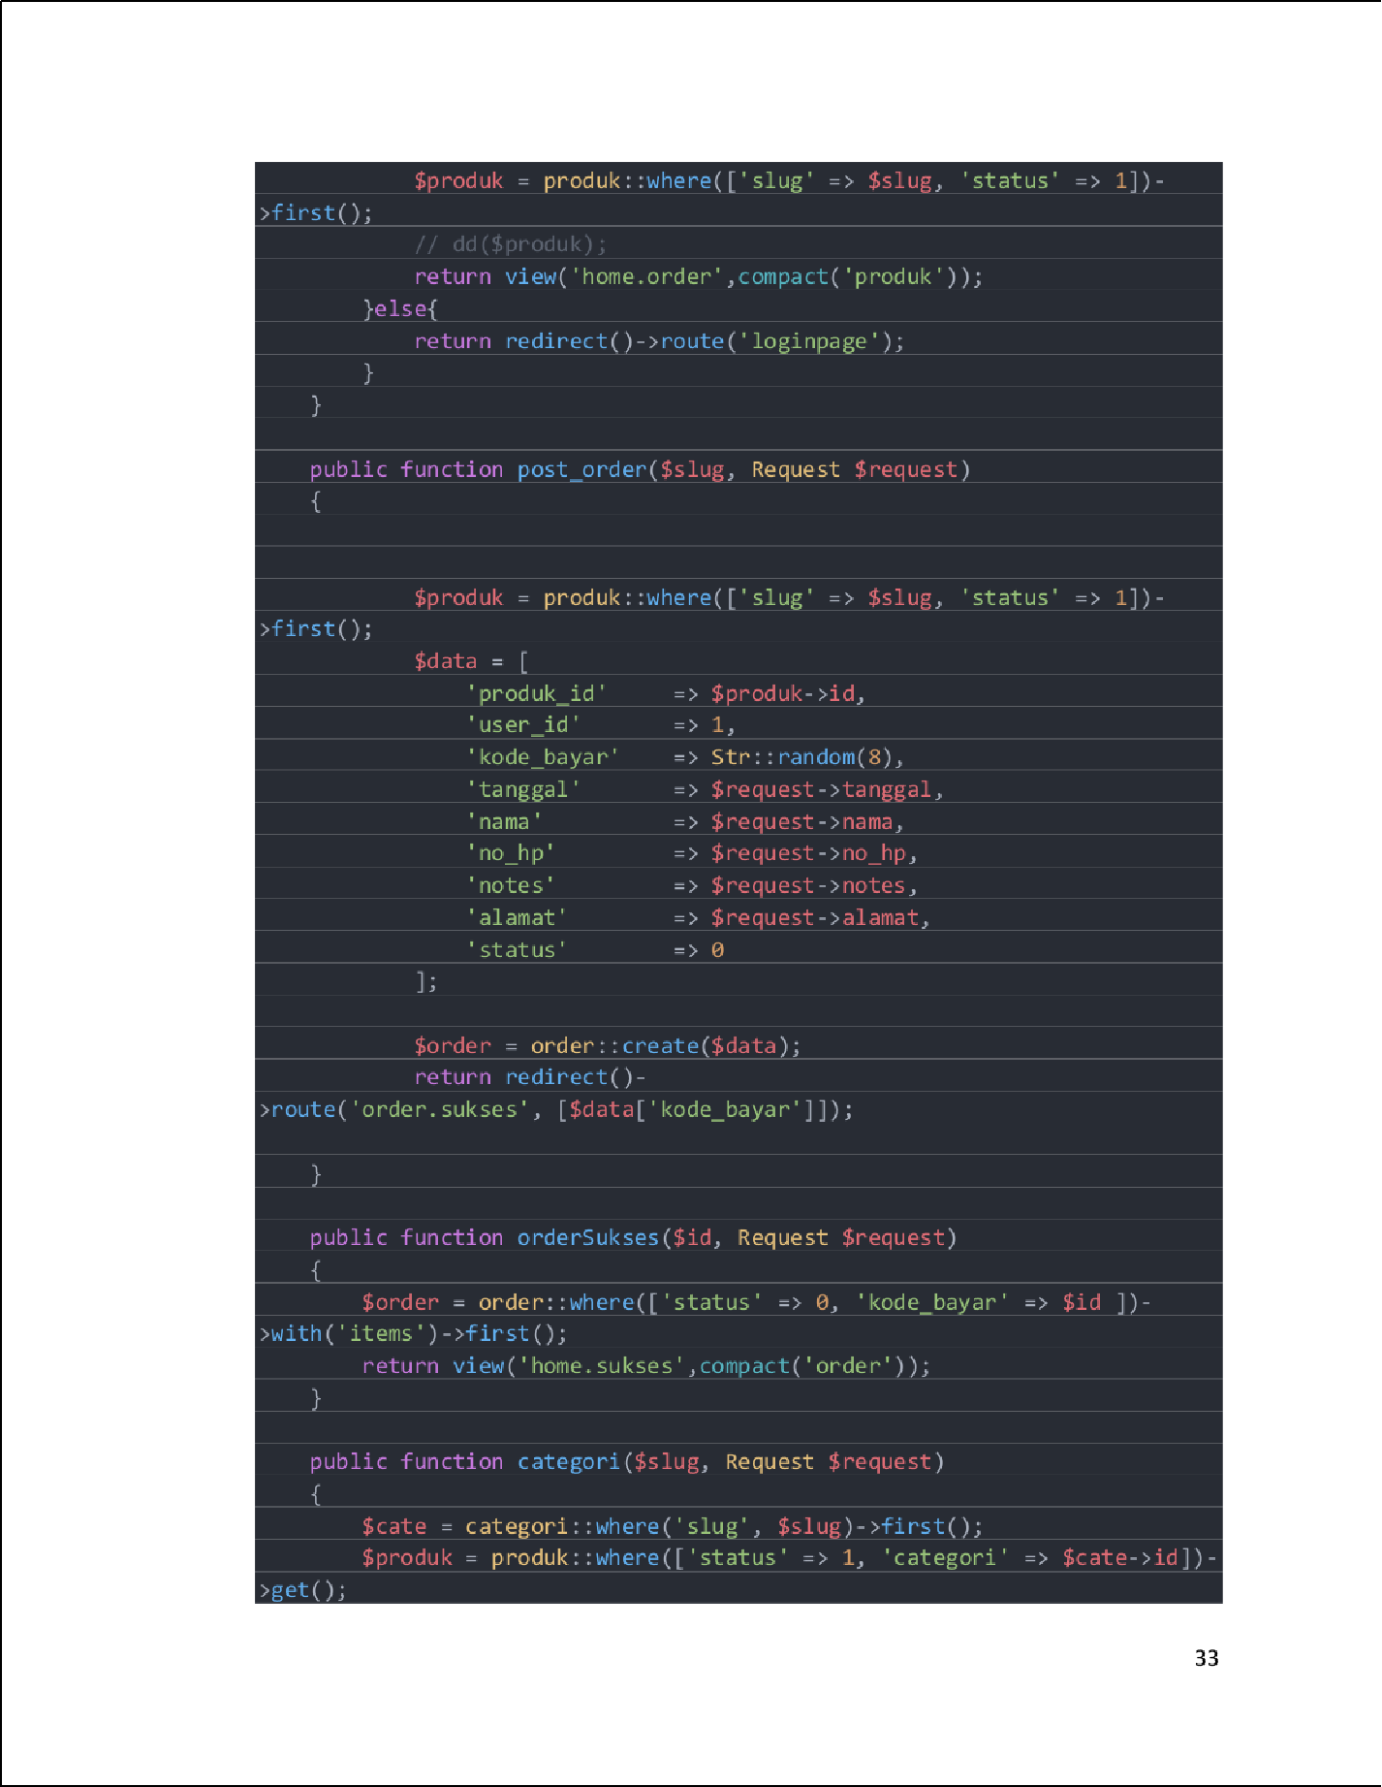

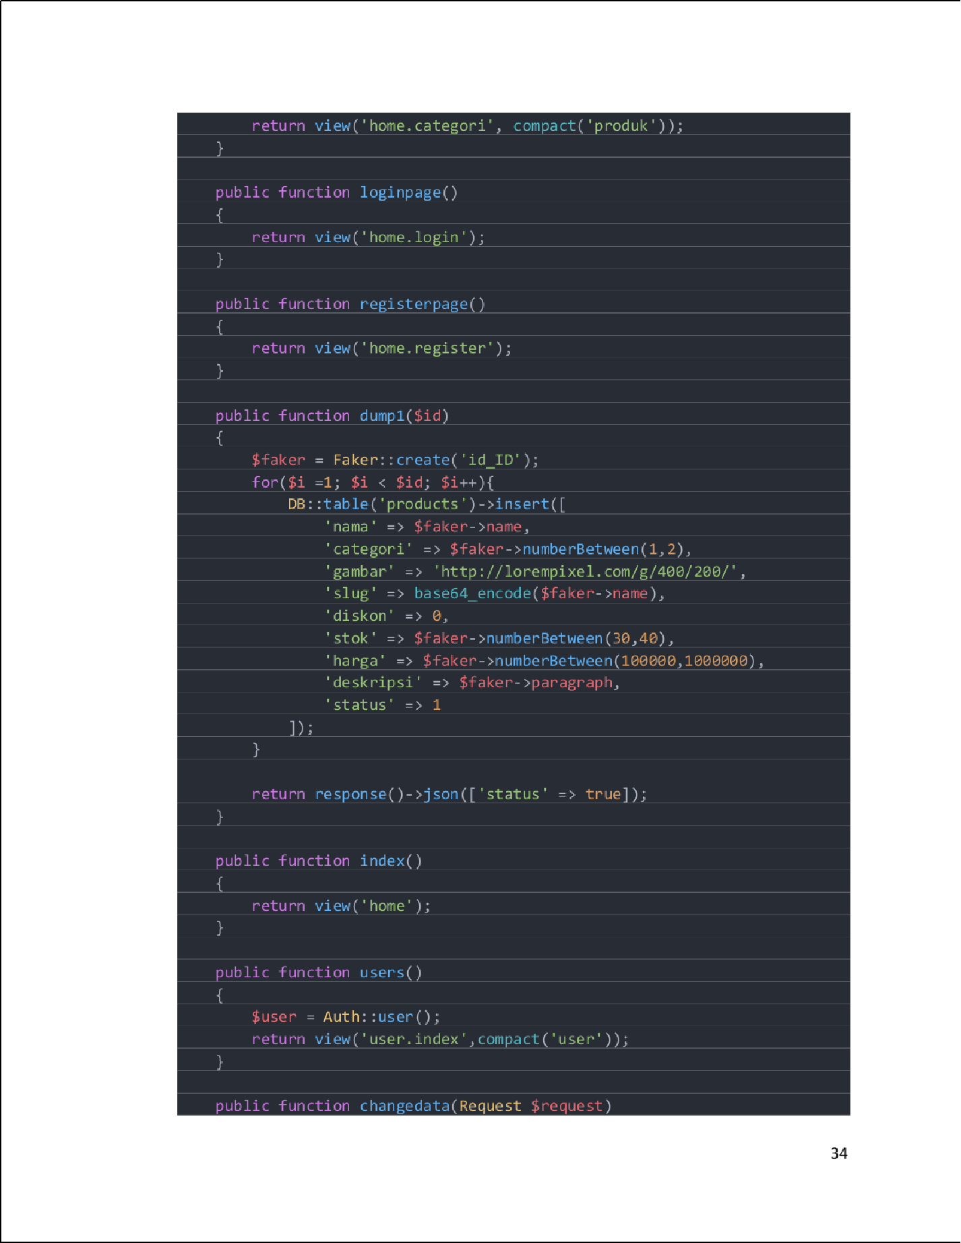

14

53

58

35

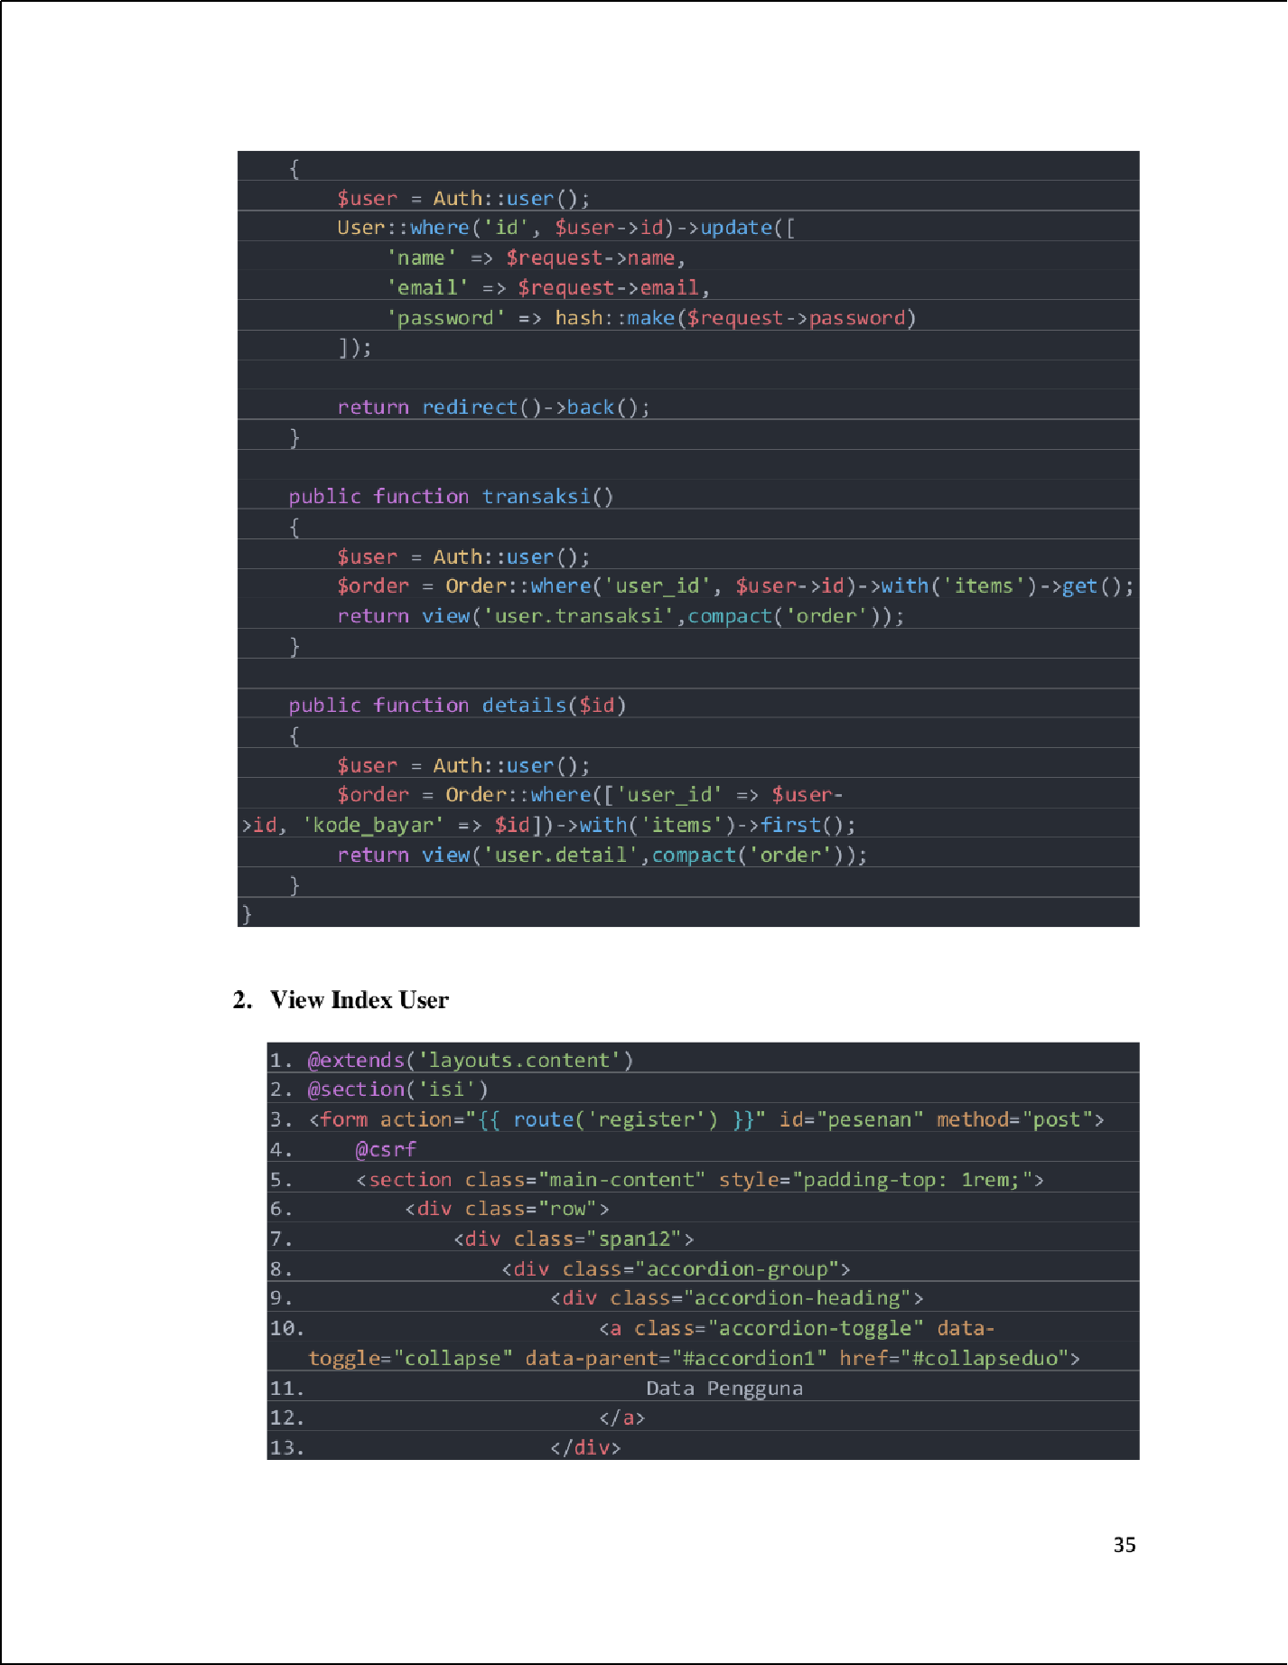

14

57

47

55

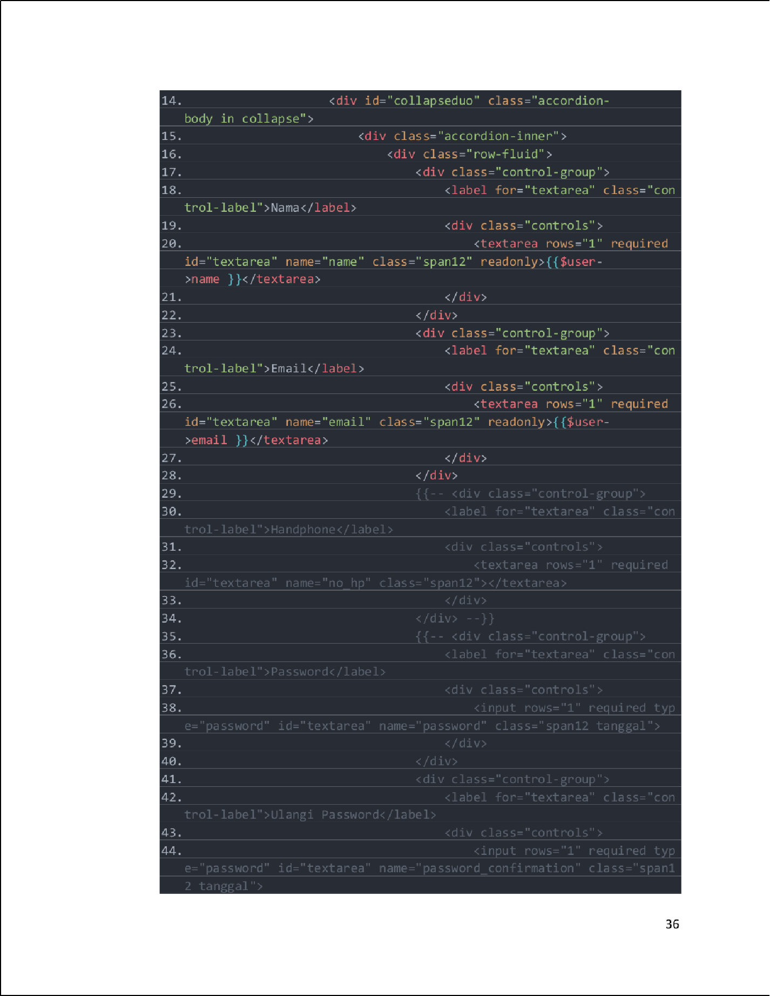

10

54

10

10

48

45

|  |
| --- |
|  |
|  |
|  |
|  |

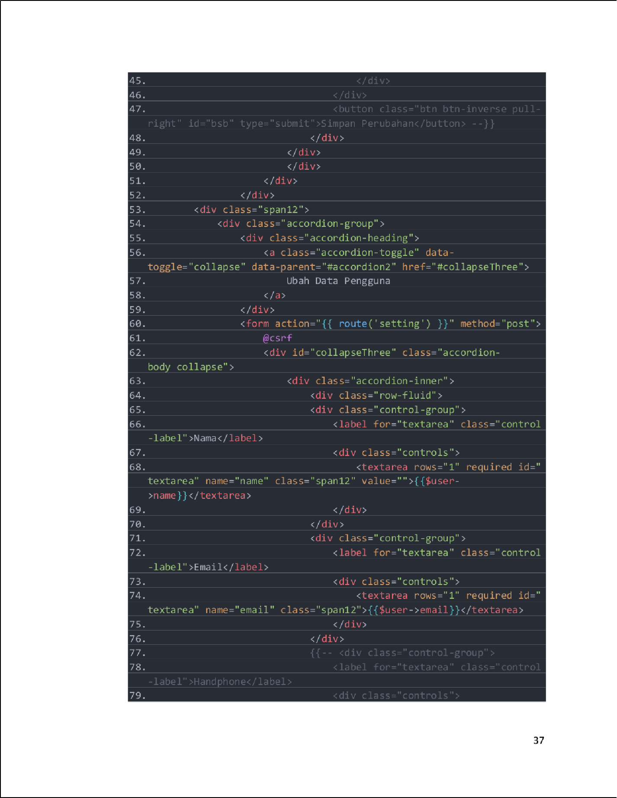

33

55

68

10

10

10

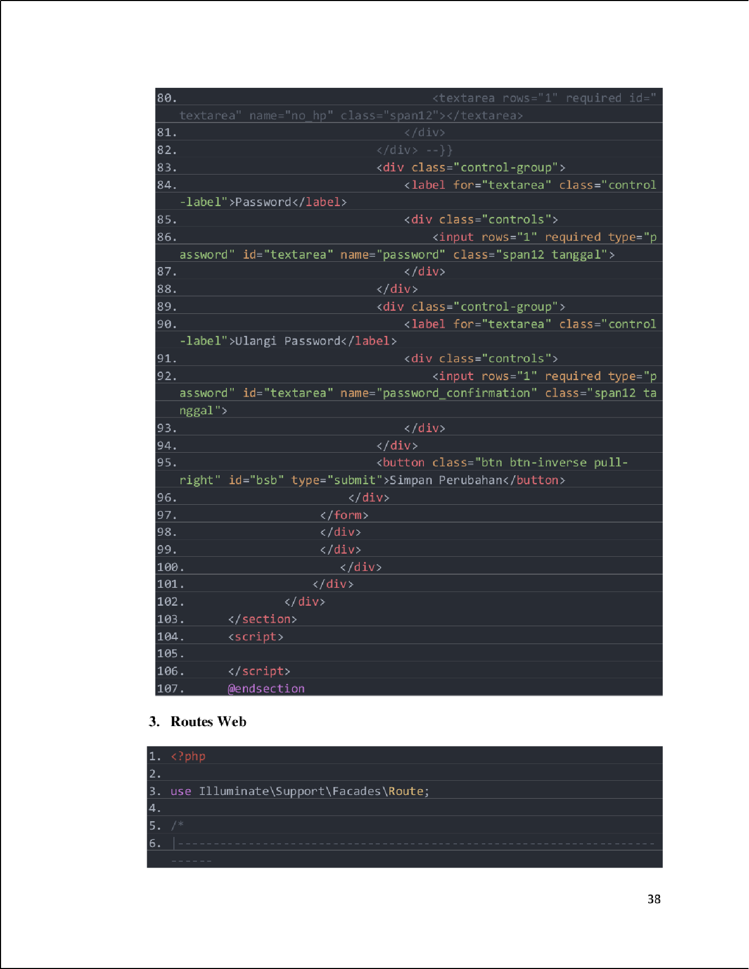

4

2

60

39

16

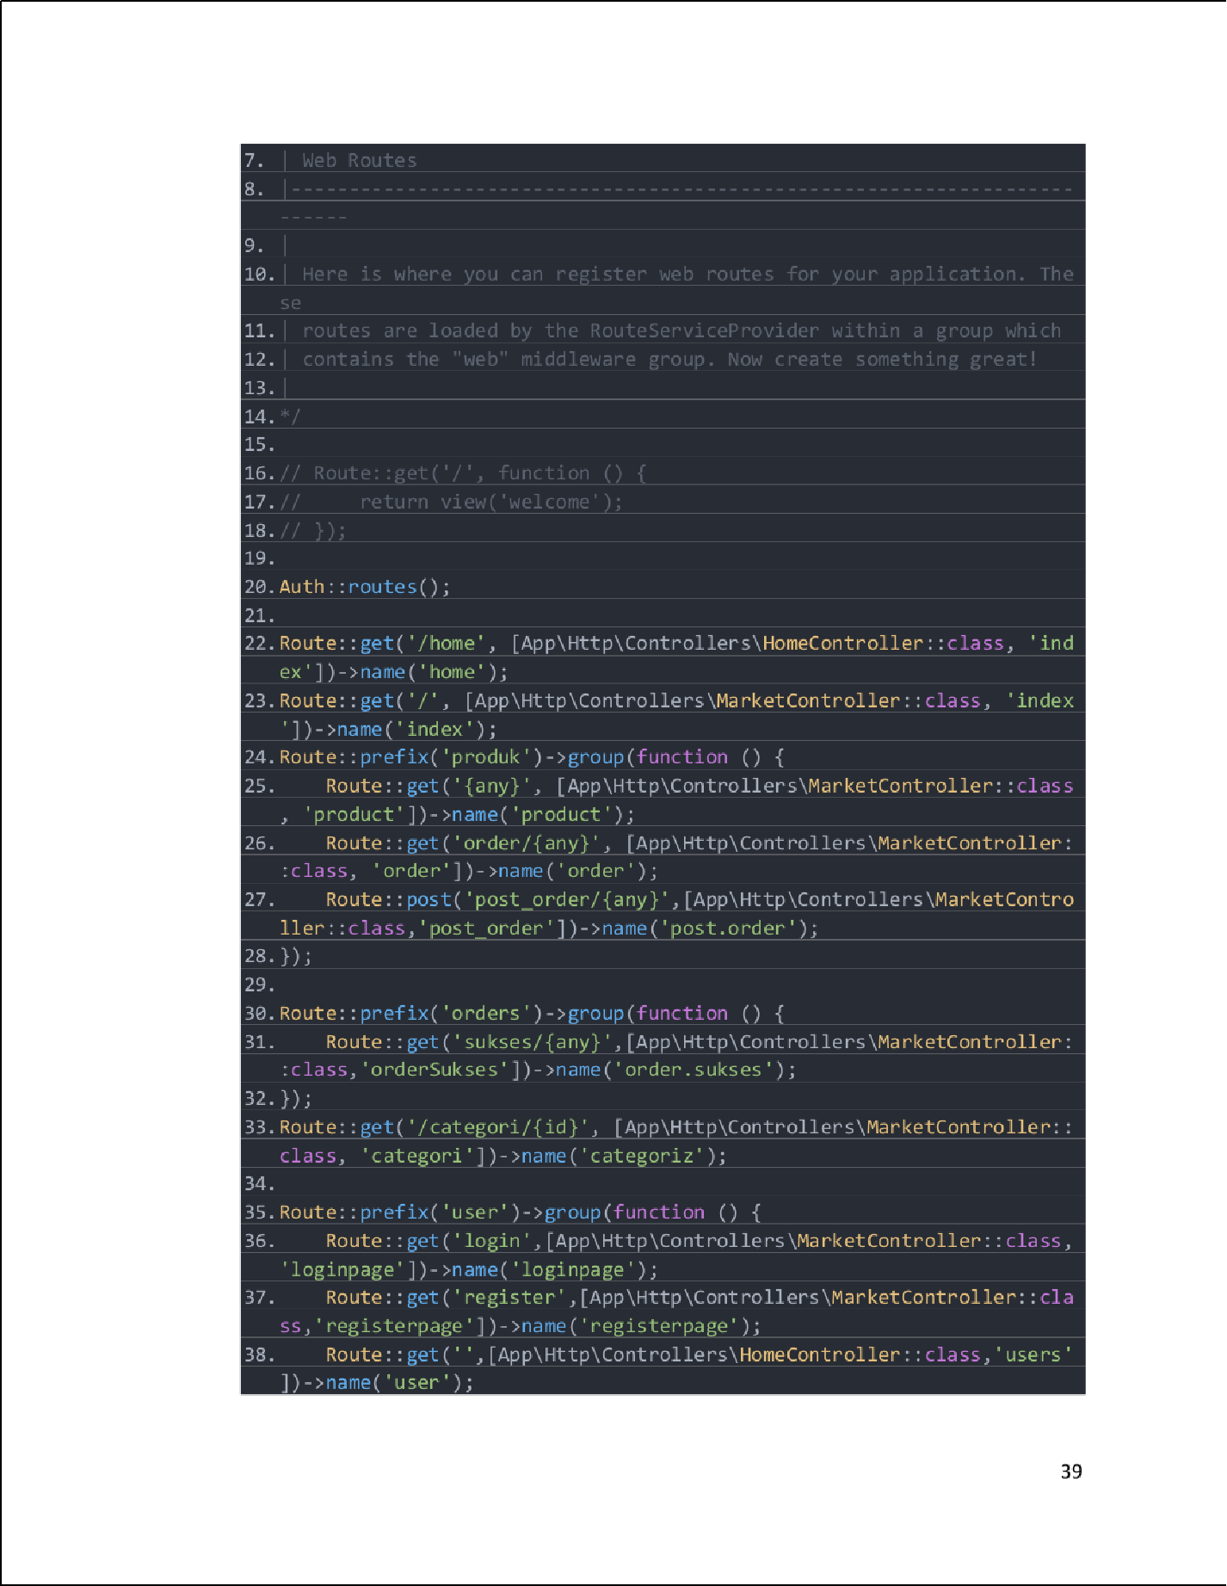

38

2

6

26

5

2

25

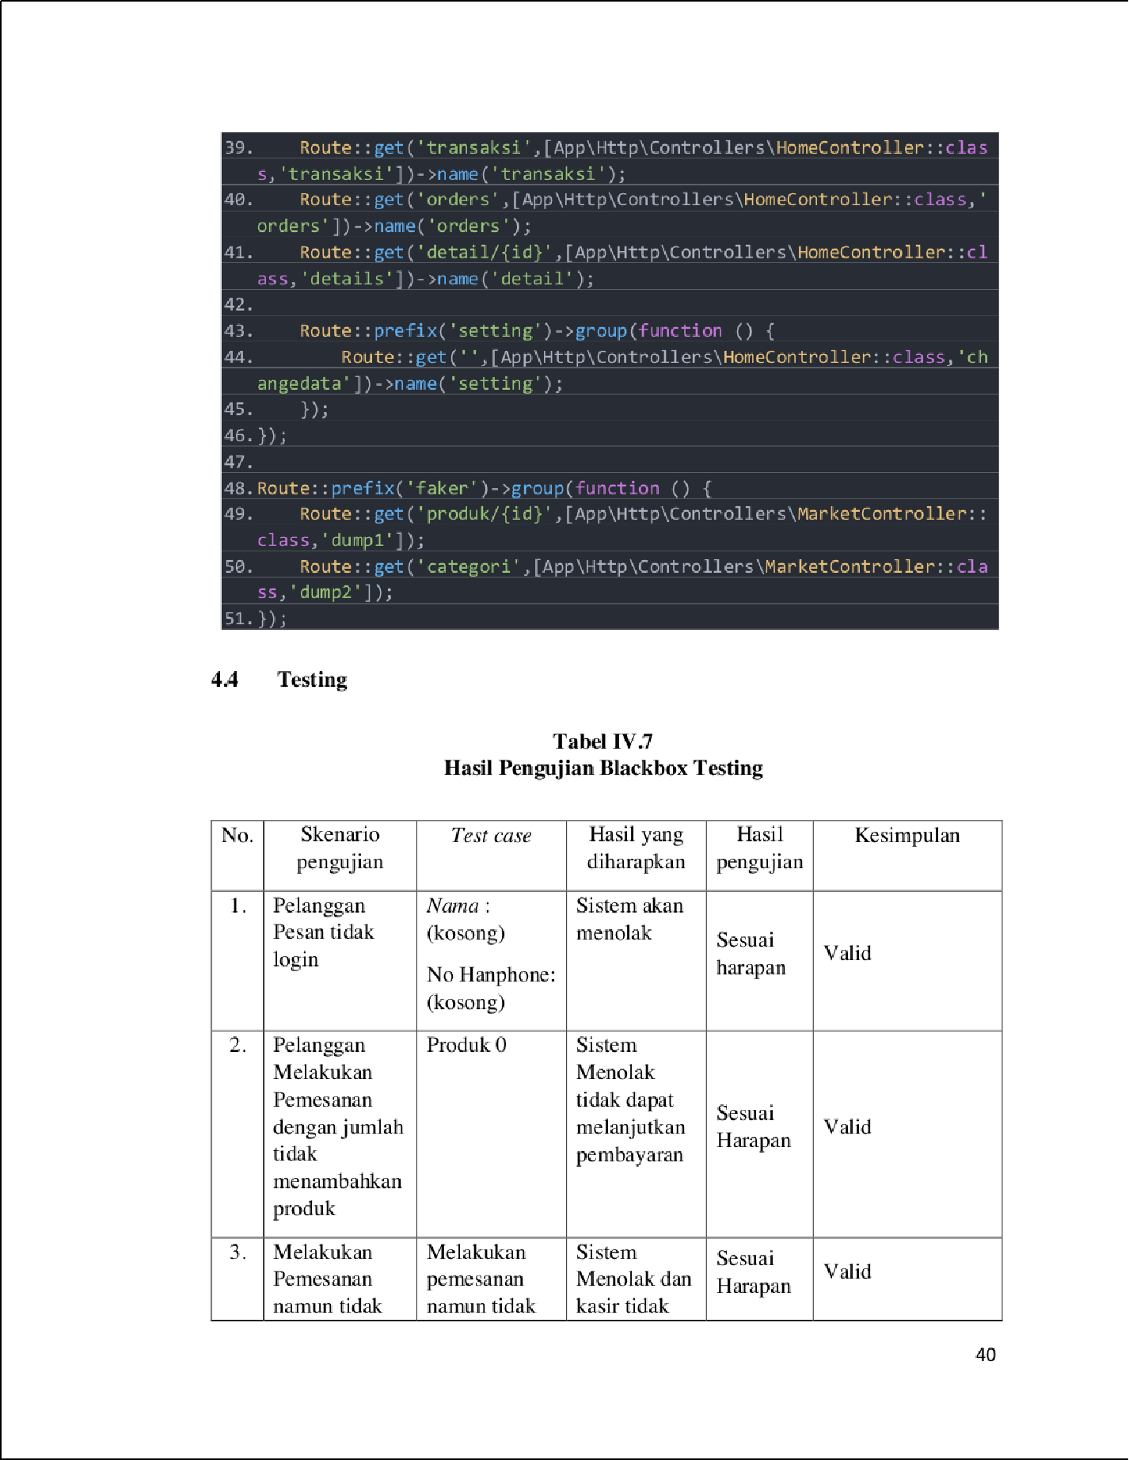

63

3

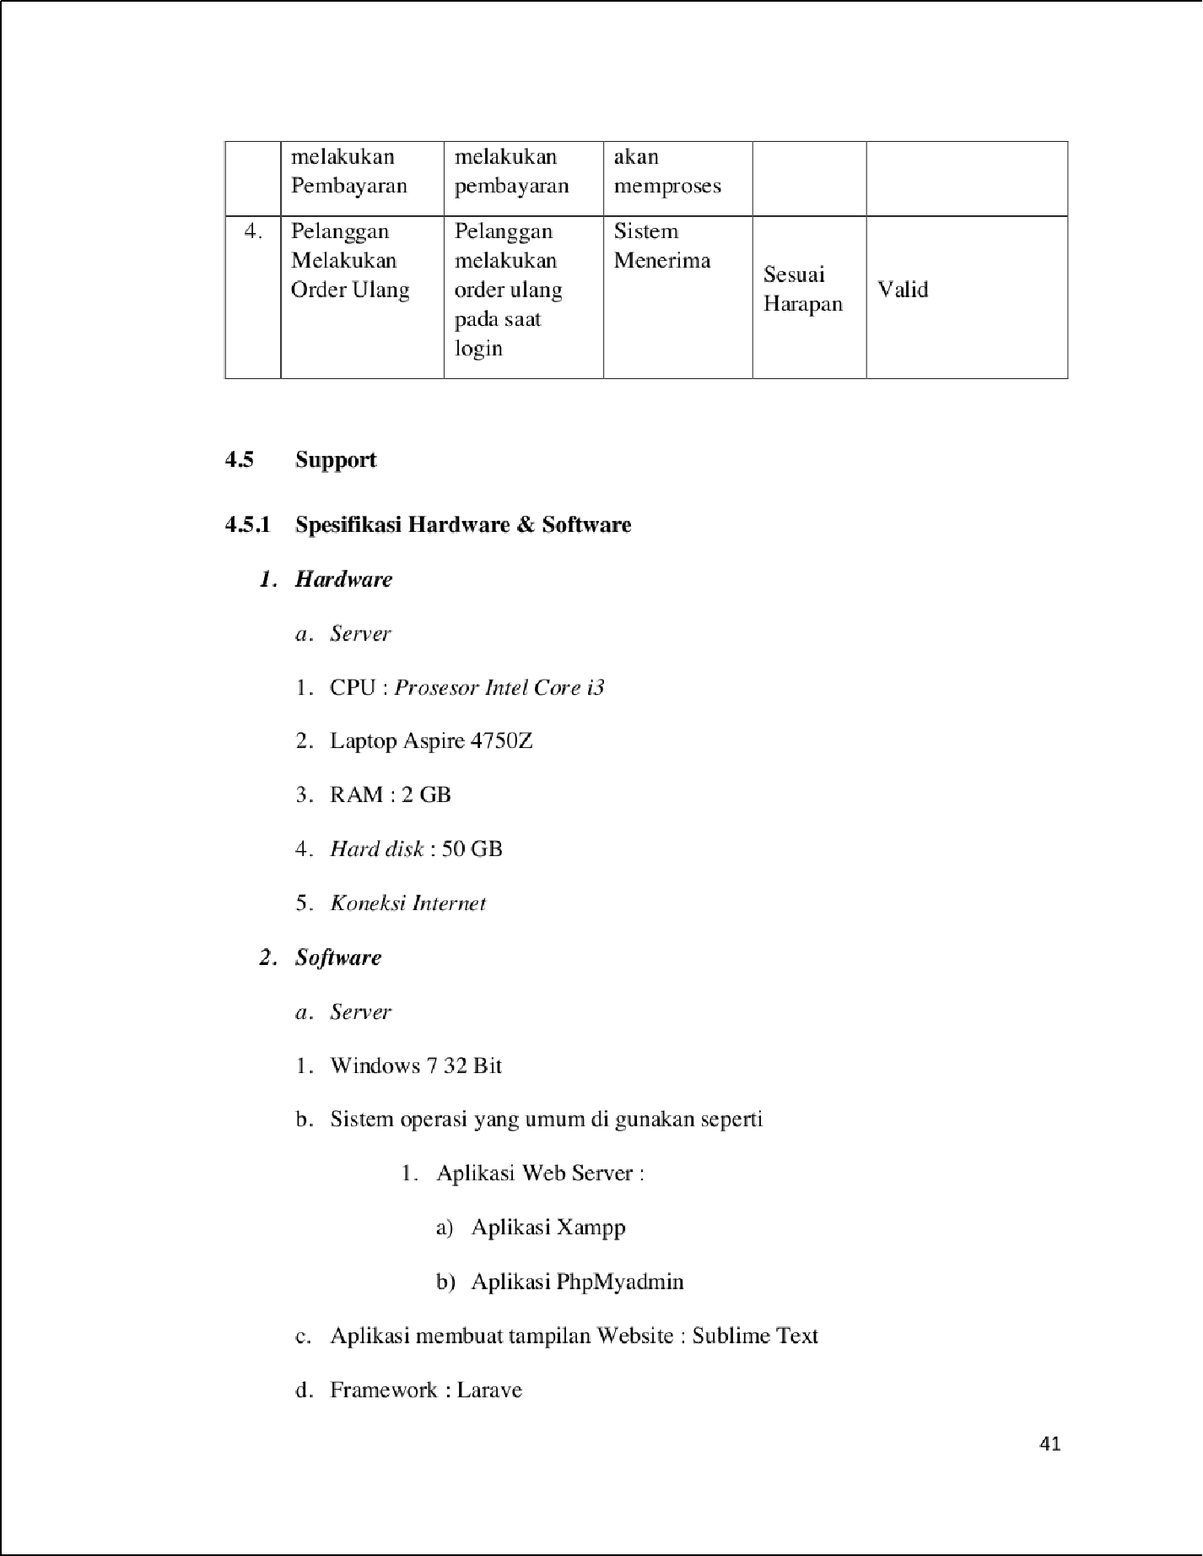

20

1

1

1

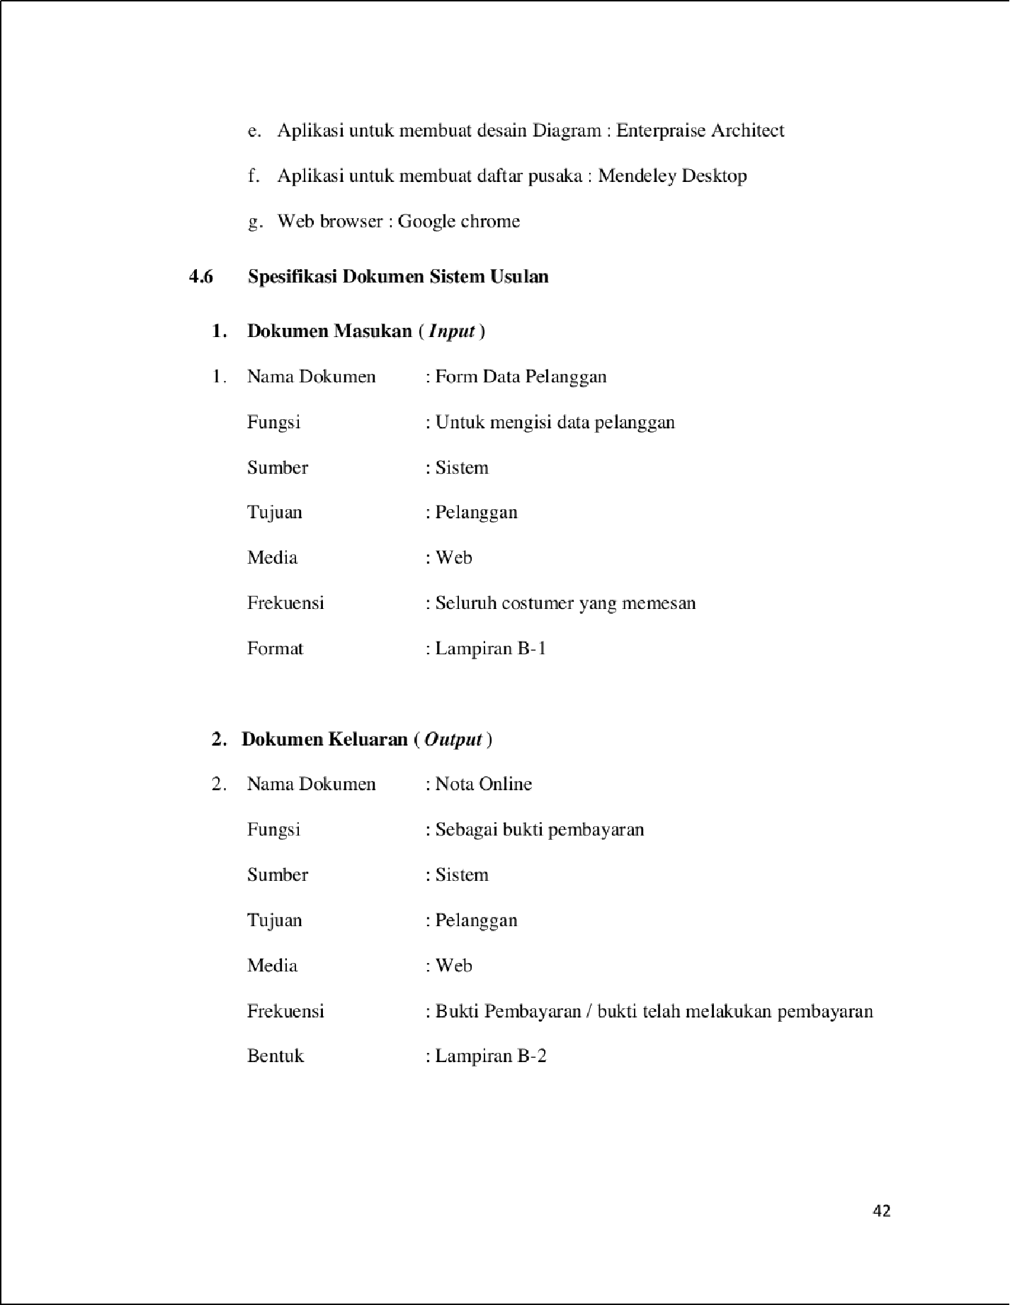

1

1

1

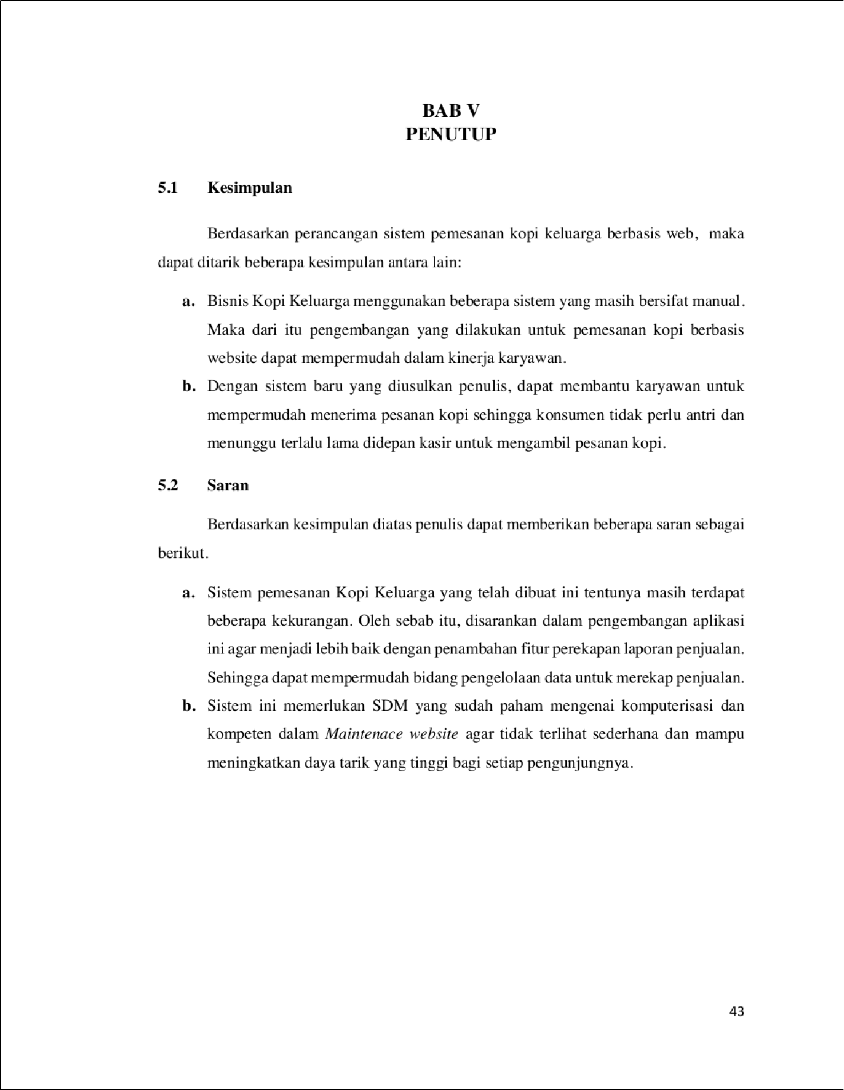

43

50

28

37

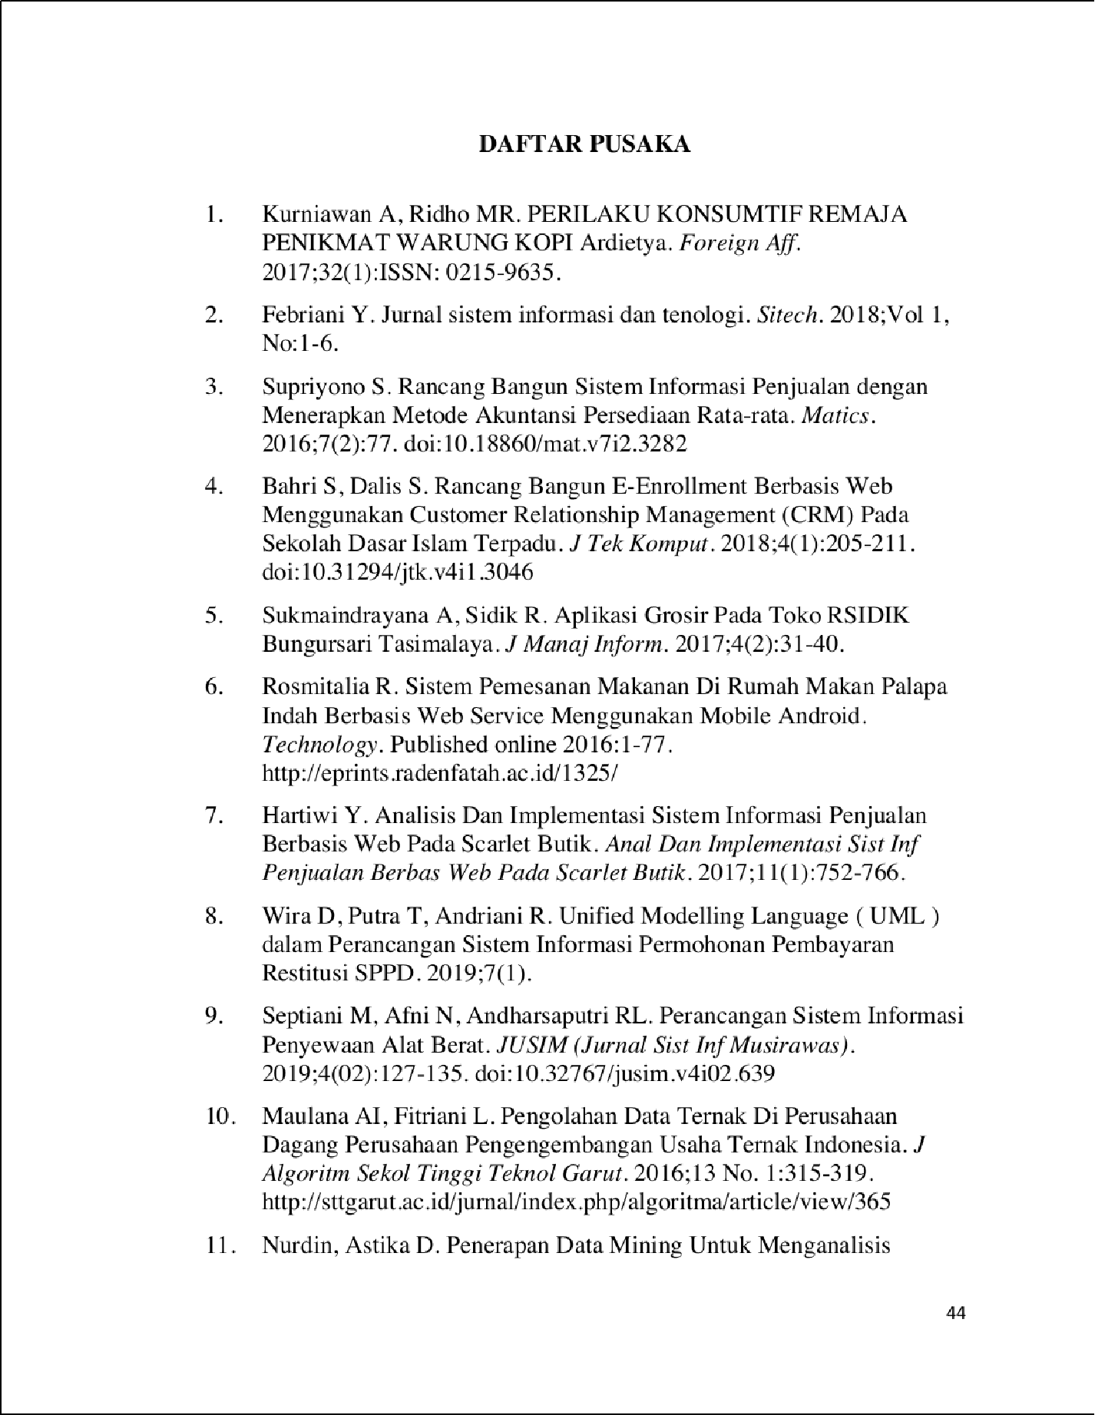

32

1

52

31

13

41

46

59

8

|  |  |  |  |  |  |  |  |
| --- | --- | --- | --- | --- | --- | --- | --- |
|  |  | | | | | | |
|  | | | | | | | |
|  | |  |  |  |  |  |  |
|  | | | | |  | |

27

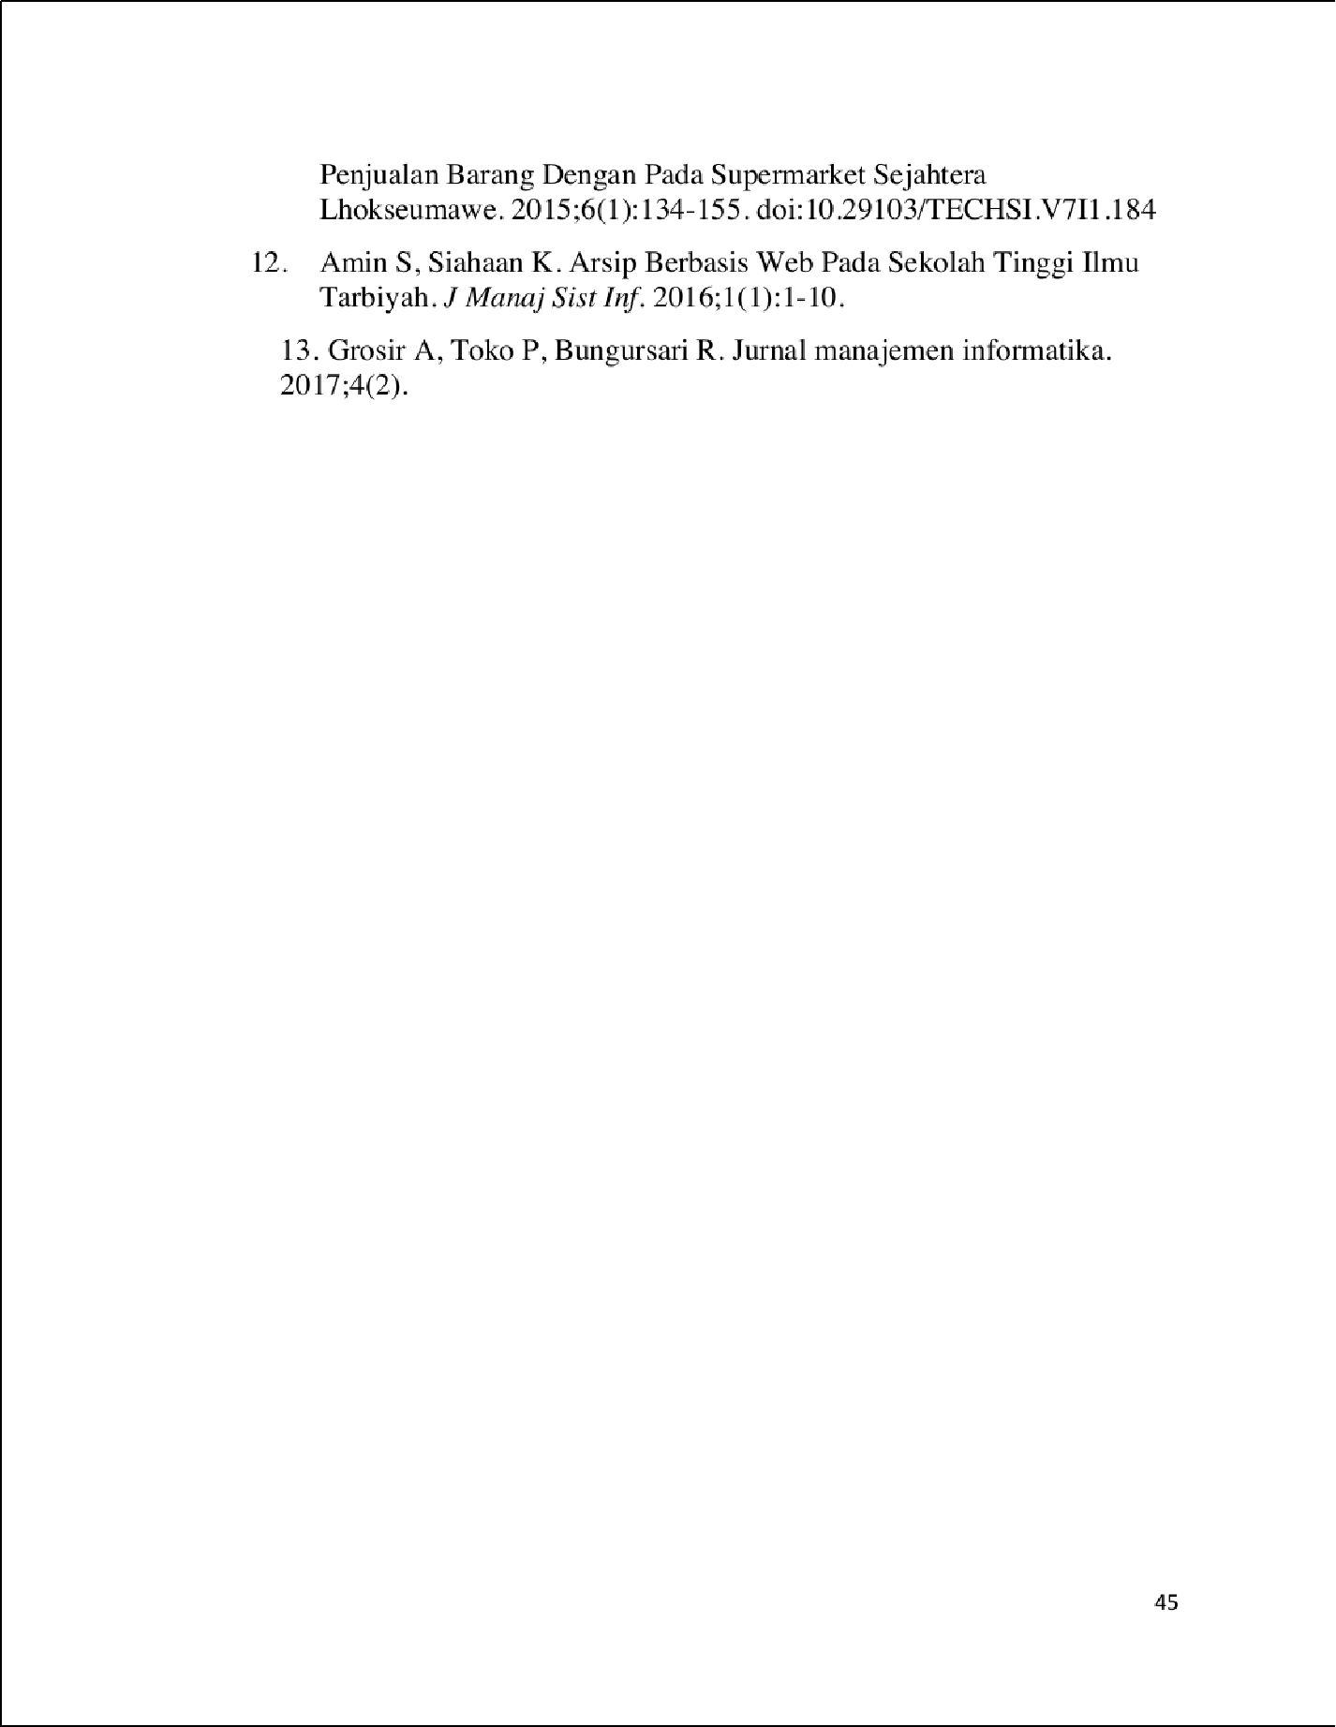

62

40



SKRIPSI_ASEP2

ORIGINALITY REPORT

54

%

SIMILARITY INDEX

52%

INTERNET SOURCES

25%

PUBLICATIONS

33%

STUDENT PAPERS

PRIMARY SOURCES

repository.bsi.ac.id

Internet Source %

1

5

3

id.123dok.com

Internet Source %

2

3

123dok.com

Internet Source %

3

2

[www.coursehero.com](http://www.coursehero.com/)

Internet Source %

4

2

jurnal.univbinainsan.ac.id

Internet Source %

5

2

jurnal.uns.ac.id

Internet Source %

6

2

core.ac.uk

Internet Source %

7

2

proceeding.unindra.ac.id

Internet Source %

8

2

jurnal.umk.ac.id

Internet Source %

9

10

11

12

13

14

15

16

17

18

19

20

21

Submitted to National Tertiary Education Consortium

Student Paper

2%

jurnal.stmik-dci.ac.id

2

Internet Source %

ojs.unimal.ac.id

2

Internet Source %

eprints.uty.ac.id

1

Internet Source %

Submitted to University of Northampton

1

Student Paper %

jurnal.unprimdn.ac.id

1

Internet Source %

develop.ﬁnki.ukim.mk

1

Internet Source %

Submitted to Sriwijaya University

1

Student Paper %

belajarbersamatik.ﬁles.wordpress.com

1

Internet Source %

repository.uma.ac.id

1

Internet Source %

repository.nusamandiri.ac.id

1

Internet Source %

yayugartika.blogspot.com

22

23

24

25

26

27

28

29

30

31

Internet Source

eprints.umbjm.ac.id

Internet Source

Herpendi Herpendi. "Sistem Informasi Desa di Kecamatan Takisung", Jurnal Sains dan Informatika, 2017

Publication

repository.wicida.ac.id

Internet Source

Submitted to Harare Institute of Technology

Student Paper

Submitted to Aristotle University of Thessaloniki

Student Paper

ejournal.upbatam.ac.id

Internet Source

repository.dinamika.ac.id

Internet Source

docplayer.info

Internet Source

text-id.123dok.com

Internet Source

Submitted to Universitas Mercu Buana

Student Paper

1%

1%

1%

1%

1%

1%

1%

1%

1%

1%

<1%

32

33

34

35

36

37

38

39

40

41

doaj.org

Internet Source

Submitted to NCC Education

Student Paper

jurnal.nusaputra.ac.id

Internet Source

scholar.unand.ac.id

Internet Source

Dewi Yuliandari, Oryza Gilang, Feri Prasetyo. "Rancang Bangun Sistem Informasi Pariwisata Kecamatan Muaragembong Berbasis Web", Jurnal Sisfokom (Sistem Informasi dan Komputer), 2017

Publication

[www.scribd.com](http://www.scribd.com/)

Internet Source

Submitted to Arab Open University

Student Paper

git.kpi.fei.tuke.sk

Internet Source

widuri.raharja.info

Internet Source

eprintslib.ummgl.ac.id

Internet Source

<1%

<1%

<1%

<1%

<1%

<1%

<1%

<1%

<1%

<1%

42

43

44

45

46

47

48

49

50

51

Submitted to University of Missouri, Kansas City

Student Paper

repository.uinjkt.ac.id

Internet Source

eprints.poltektegal.ac.id

Internet Source

projects.ecoinformatics.org

Internet Source

Ricki Sastra, Gugum Gumelar. "Rancang Bangun Aplikasi Sistem Peminjaman Unit Multimedia Menggunakan Metode Waterfall", INSANtek, 2021

Publication

dspace.cas.upm.edu.ph

Internet Source

Submitted to Middlesex University

Student Paper

adoc.pub

Internet Source

repository.amikom.ac.id

Internet Source

comdev.pubmedia.id

Internet Source

<1%

<1%

<1%

<1%

<1%

<1%

<1%

<1%

<1%

<1%

52

53

54

55

56

57

58

59

60

61

Hendri .. "PENERAPAN MODEL WATERFALL PADA PERANCANGAN PROGRAM PEMESANAN BERBASIS DESKTOP", Jurnal

Infortech, 2020

Publication

[www.malasngoding.com](http://www.malasngoding.com/)

Internet Source

madcoder.org

Internet Source

[www.sthik.com](http://www.sthik.com/)

Internet Source

xcontohmakalah.blogspot.com

Internet Source

Submitted to Republic of the Maldives

Student Paper

collaborating.tuhh.de

Internet Source

repository.atmaluhur.ac.id

Internet Source

Submitted to Center of Pedagogical Measurements of Nazarbayev Intellectual Schools JSC

Student Paper

Yulia Yulia, Nanda Diaz Arizona, Tasya Anisa. "Sistem Informasi Akuntansi Pendapatan Jasa

<1%

<1%

<1%

<1%

<1%

<1%

<1%

<1%

<1%

<1%

62

63

64

65

66

67

68

Dan Penjualan Suku Cadang Pada Bengkel Podomoro Motor Pontianak Berbasis Web", Jurnal Sistem Informasi Akuntansi, 2021

Publication

akamigas.esdm.go.id

Internet Source

blog.nubecolectiva.com

Internet Source

ejournal.lppmsttpagaralam.ac.id

Internet Source

ejurnal.stmik-budidarma.ac.id

Internet Source

Muhammad Dedi Irawan, Selli Aprilla Simargolang. "Implementasi E-Arsip Pada Program Studi Teknik Informatika", JURNAL TEKNOLOGI INFORMASI, 2018

Publication

repo.unand.ac.id

Internet Source

[www.ayongoding.com](http://www.ayongoding.com/)

Internet Source

<1%

<1%

<1%

<1%

<1%

<1%

<1%

Exclude quotes On Exclude bibliography On

Exclude matches Oﬀ